Enhancing Cybersecurity in Corporate Environments through OpenCV-Based Facial Recognition Attendance System with Intruder Detection

**Project submitted to Asian School of Media Studies in**

**partial fulfillment of the requirements for the award of**

**degree of**

**B.Sc.**

**In**

**Data Science**

**By**

**Aman Pandey**

**(University Roll No: 12112936001 )**

**Under the Supervision of**

**Dr. Aashima Bangia**

## 

**ASIAN SCHOOL OF MEDIA STUDIES**

**NOIDA**

**2024**

**Declaration**

I, **Aman Pandey**, S/O **Dinesh Pandey**, declare that my project entitled “**Enhancing Cybersecurity in Corporate Environments through OpenCV-Based Facial Recognition Attendance System with Intruder Detection**”, submitted at **School of Data Science, Asian School of Media Studies, Film City, Noida**, for the award of M.Sc. in Data Science, Noida International University, is an original work and no similar work has been done in India anywhere else to the best of my knowledge and belief.

This project has not been previously submitted for any other degree of this or any other University/Institute.

 

**Acknowledgements**

The completion of the project titled “**Enhancing Cybersecurity in Corporate Environments through OpenCV-Based Facial Recognition Attendance System with Intruder Detection**”, gives me an opportunity to convey my gratitude to all those who helped to complete this project successfully. I express special thanks:

To **Prof. Sandeep Marwah**, President, Asian School of Media Studies, who has been a source of perpetual inspiration throughout this project.

To **Mr. Ashish Garg**, Director for School of Data Science for your valuable guidance, support, consistent encouragement, advice and timely suggestions.

To **Dr. Aashima Bangia**, Assistant Professor of School of Data Science, for your encouragement and support. I deeply value your guidance.

To **my friends** for their insightful comments on early drafts and for being my worst critic. You are all the light that shows me the way.

To all the people who have directly or indirectly contributed to the writing of this thesis, but their names have not been mentioned here.



**Abstract**

The advancement of cybersecurity within corporate environments is increasingly reliant on innovative technologies that can enhance both security and operational efficiency. This research paper presents a comprehensive study on the integration of an OpenCV-based facial recognition attendance system with intruder detection capabilities. The proposed system leverages the robustness of computer vision and machine learning techniques to ensure secure and efficient management of employee attendance while simultaneously enhancing corporate security by detecting unauthorized access attempts.The study begins with an in-depth exploration of the dataset used for training and testing the facial recognition system. High-quality facial images of authorized personnel are collected and preprocessed to create a robust dataset. Preprocessing steps include converting images to a consistent format, resizing, and normalizing them to ensure uniformity. These images are then encoded into numerical face representations using advanced face recognition algorithms. The dataset is carefully curated to include multiple images per individual, captured under varying conditions to enhance the system's ability to recognize faces accurately.The core of the system's functionality lies in its ability to identify faces in real-time using a live video feed from a webcam. The system captures frames from the webcam, processes them to detect faces, and compares the detected faces against the pre-encoded dataset to identify authorized individuals. This real-time face recognition is achieved using a combination of OpenCV for image processing and the `face_recognition` library for facial feature extraction and comparison. The system's performance is evaluated based on its accuracy in recognizing authorized personnel and its efficiency in marking attendance.In addition to attendance management, the system includes an intruder detection feature designed to enhance corporate security. When an unrecognized face is detected, the system triggers an alert mechanism to notify security personnel of a potential breach. This dual functionality ensures that the system not only streamlines attendance tracking but also acts as a proactive security measure.The paper provides a detailed analysis of the system's architecture, including the methods used for face detection, face encoding, and face comparison. It also discusses the challenges encountered during the implementation, such as variations in lighting conditions, facial expressions, and occlusions, and how these challenges were addressed to improve the system's robustness.Furthermore, the paper delves into the ethical considerations of using.facial recognition technology in corporate environments. It discusses the balance between security benefits and privacy concerns, emphasizing the importance of transparent data handling practices and obtaining informed consent from employees.The research concludes with an evaluation of the system's performance based on empirical data collected during testing. Metrics such as recognition accuracy, false acceptance rate (FAR), and false rejection rate (FRR) are used to assess the system's effectiveness. The results demonstrate that the proposed system provides a reliable and efficient solution for enhancing cybersecurity and managing attendance in corporate environments. Overall, this research paper contributes to the field of cybersecurity by presenting a novel application of facial recognition technology for corporate security and attendance management. It highlights the potential of integrating computer vision and machine learning techniques to create systems that not only improve operational efficiency but also offer robust security measures to protect corporate assets and personnel.

**List of Figures**

1. Facial Landmark Mapping with Geometric Grid Overlay for Recognition and Analysis 16
2. Facial Recognition System for Access Permission with Advanced Digital Overlays 18
3. Why we choose Face recognition 21
4. Workflow of a Facial Recognition-Based Attendance System 51
5. Detailed Facial Analysis with Annotations for Recognition and Detection 59
6. Input Photo and Corresponding 128-Point Facial Feature Data for Digital Face Representation 61
7. Attendance_sheet.csv 65
8. Facial Landmark Annotation and Geometric Mesh Visualization for Facial Recognition 73
9. Flowchart of the Facial Recognition System Process 77
10. Key Stages in the Facial Recognition Process 78
11. Precision-Recall Graph 83
12. Illustration of our model using faces from the database in real time (part a) 85
13. Illustration of our model using faces from the database in real time (part b) 85
14. Illustration of our model using faces that are not from the database in real time (part a) 86
15. Illustration of our model using faces that are not from the database in real time (part b) 87
16. Facial recognition system accuracies 96

**List of Tables**

1. Comparison of Face Recognition Systems for Various Applications 33
2. Comparison of Identification Methods Based on Key Criteria 45
3. Accuracy Comparison Table 95

**Abbreviations**

AI : Artificial Intelligence

CV : Computer Vision

CSV : Comma-Separated Values

FPS : Frames Per Second

IoT : Internet of Things

ML : Machine Learning

RGB : Red, Green, Blue

ROI : Region of Interest

RTSP : Real-Time Streaming Protocol

SVM : Support Vector Machine

EDA : Exploratory Data Analysis

CNN : Convolutional Neural Network

DL : Deep Learning

**Contents**

**Declaration 1**

**Acknowledgements 2**

**Abstract 3**

**List of Tables 6**

**List of Figures 7**

**Abbreviations 8**

**Chapter 1. OpenCV-Based Facial Recognition 10**

1.1 Introduction 10

1.1.1 Background 10

1.1.2 Problem Statement 13

1.1.3 Objectives 16

1.1.4 Significance of the study 21

1.1.5 Outline of The Study 24

1.1.6 Motivation 28

1.2 Literature review 29

1.3 Abbreviations/Definitions 42

**Chapter 2. Dataset 45**

2.1 Collection 45

2.1.1 Image Quality 45

2.1.2 Naming Convention 46

2.1.3 Storage Structure 46

2.2 Exploratory Data Analysis (EDA) 46

2.2.1 Summary Statistics 47

2.2.2 Visualization 48

2.2.3 Anomaly Detection 48

**Chapter 3. Case Study 49**

3.1 Introduction to Case Study 49

3.2 Challenges and Drawbacks 51

**Chapter 4. Model Selection 54**

4.1 Methodology Overview 54

4.1.1. Requirement Analysis 55

4.1.2. Exploration of DL Techniques 56

4.1.3. Architectural Design 59

4.1.4. Evaluation Criteria Establishment 59

4.2 Model Building 60

4.3 Deep Learning Technique with Mathematical Intuitions 67

4.4 Implementation With Dataset 71

**Chapter 5. Results and Discussions 76**

5.1 Results 77

5.2 Performance Metrics 80

5.3 Discussion of Results 84

5.4 Conclusion 87

5.5 Future Scope 91

**Chapter 6. Bibliography 108**

**Chapter 7. Appendix 115**

7.1 Import Libraries 115

7.2 Create Encodings 116

7.3 Real-Time Video Capturing 117

7.4 Precision Recall Graph 118

**Chapter 1. OpenCV-Based Facial Recognition**

# **1.1 Introduction**

Facial recognition technology has seen significant advancements in recent years, becoming a cornerstone in various applications ranging from security systems to personal device authentication. This project aims to enhance corporate security by developing a robust facial recognition system capable of accurately identifying authorized personnel and detecting unauthorized access attempts in real-time. Leveraging advanced computer vision techniques and machine learning algorithms, the system is designed to operate effectively under diverse conditions, including varying lighting, facial expressions, and occlusions.

Key aspects of the system include the implementation of state-of-the-art face detection and recognition algorithms, the creation of a comprehensive database of facial encodings for authorized individuals, and the development of a real-time alert mechanism for security breaches. By addressing challenges related to environmental and personal variations, and ensuring adherence to ethical standards and data protection regulations, the project seeks to provide a reliable, efficient, and user-friendly solution for enhancing security and operational efficiency in corporate environments.

## **1.1.1 Background**

**Evolution of Cybersecurity in Corporate Environments**

The rapid advancement of technology has brought significant changes to corporate environments, making them more interconnected and dependent on digital infrastructure. This digital transformation has led to increased productivity and efficiency but has also introduced new security challenges. Cybersecurity has evolved as a critical domain to protect sensitive corporate data, intellectual property, and personnel information from malicious attacks and unauthorized access. Traditional security measures, such as password protection and physical access controls, are increasingly proving inadequate against sophisticated cyber threats. As a result, there is a growing need for more advanced and reliable security solutions.

**The Role of Biometrics in Enhancing Security**

Biometric authentication has emerged as a powerful tool in the fight against cyber threats. Unlike traditional authentication methods that rely on something you know (passwords) or something you have (access cards), biometrics are based on something you are—unique physiological or behavioral characteristics. These characteristics are difficult to forge or steal, making biometric systems highly secure. Among various biometric modalities, facial recognition stands out due to its non-intrusive nature and ease of implementation. It does not require direct contact and can be

seamlessly integrated into existing security systems, making it an ideal choice for enhancing cybersecurity in corporate environments.

**Integration of Facial Recognition with Attendance Systems**

Managing employee attendance is a crucial aspect of corporate operations. Traditional methods, such as manual entry and card-based systems, are prone to errors, buddy punching, and unauthorized access. Integrating facial recognition technology into attendance systems offers a dual benefit: it automates the attendance process and simultaneously enhances security by ensuring that only authorized individuals are marked present. This integration not only streamlines administrative tasks but also provides real-time data for monitoring and analysis.

**OpenCV and Face Recognition Technology**

OpenCV (Open Source Computer Vision Library) is an open-source computer vision and machine learning software library. It provides a wide range of tools for image processing and computer vision applications, making it a popular choice for developing facial recognition systems. The `face_recognition` library, built on top of OpenCV and Dlib, offers state-of-the-art face detection and recognition capabilities. By leveraging these powerful libraries, developers can create robust and efficient facial recognition systems that operate in real-time and with high accuracy.

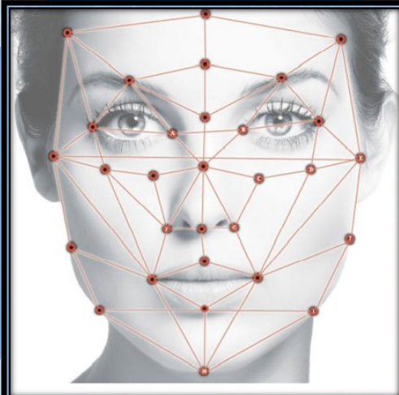Source - ShutterStock

Fig 1. Facial Landmark Mapping with Geometric Grid Overlay for Recognition and Analysis

Figure 1 depicts a face with an overlay of a geometric grid, showing key facial landmarks connected by lines. This type of visualization is commonly used in facial recognition or analysis technologies to map out significant points on the face, such as the eyes, nose, mouth, and jawline, to create a digital representation of the face for identification or analysis purposes.

**Challenges in Implementing Facial Recognition Systems**

Despite the advantages, implementing facial recognition systems in corporate environments comes with its own set of challenges. Variations in lighting conditions, facial expressions, and occlusions (such as glasses or masks) can affect the accuracy of face detection and recognition. Additionally, privacy

concerns and ethical considerations must be addressed to ensure that the deployment of such systems does not infringe on individual rights. Ensuring data security and obtaining informed consent from employees are critical steps in the responsible implementation of facial recognition technology.

## 1.1.2 Problem Statement

In today's digital age, corporate environments face unprecedented cybersecurity challenges. As organizations become more interconnected and reliant on digital infrastructure, the risk of unauthorized access and cyberattacks increases. Traditional security measures, such as passwords and access cards, are often inadequate against sophisticated threats, leading to potential breaches that can compromise sensitive corporate data and disrupt operations. Furthermore, managing employee attendance using conventional methods is prone to errors, inefficiencies, and fraudulent activities, such as buddy punching, where employees clock in for each other.

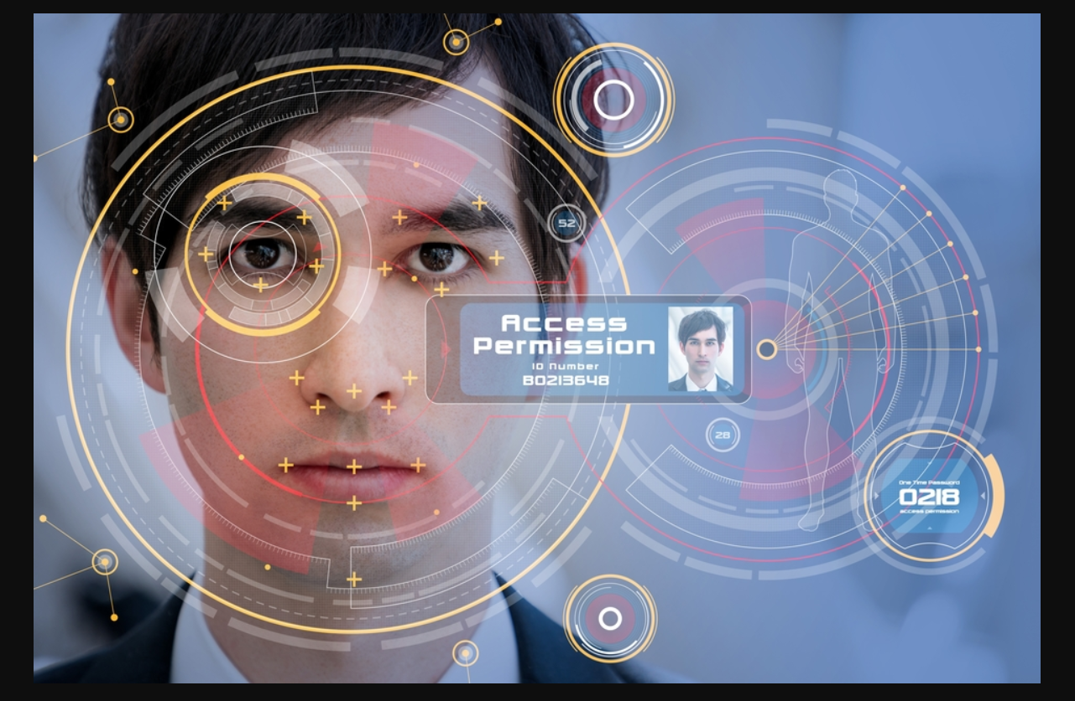

Source - Analytics Insight Fig 2. Facial Recognition System for Access Permission with Advanced Digital Overlays

Figure 2 shows a man undergoing facial recognition for access permission. Over his face, there are futuristic digital overlays with various geometric patterns, circles, and crosshairs indicating facial feature analysis. A small inset displays his photo along with an "Access Permission" label and an ID number, suggesting that the facial recognition system is verifying his identity to grant access. The overall visual design emphasizes advanced technology and security protocols.

The primary problems addressed in this research are:

**1. Inadequate Security Measures:**

- Traditional security mechanisms like passwords and access cards are vulnerable to theft, duplication, and hacking.

- There is a growing need for more reliable and secure methods to authenticate individuals accessing corporate premises and digital systems.

**2. Inefficient Attendance Management:**

- Manual attendance systems and card-based solutions are error-prone and can be easily manipulated.

- These systems do not provide real-time data and are inefficient in large

organizations, leading to administrative burdens and potential payroll inaccuracies.

**3. Lack of Real-Time Intruder Detection:**

- Current systems often fail to provide real-time alerts for unauthorized access, compromising the security of corporate environments.

- There is a need for an integrated solution that not only tracks attendance but also detects and alerts security personnel about intruders in real-time.

**4. Challenges in Facial Recognition Accuracy :**

- Variations in lighting, facial expressions, and occlusions, such as masks or glasses, can significantly affect the accuracy of facial recognition systems.

- Ensuring high accuracy and reliability of facial recognition in diverse and dynamic environments is a critical challenge.

**5. Privacy and Ethical Concerns :**

- The deployment of facial recognition systems raises concerns about privacy and the ethical use of biometric data.

- Organizations must balance the need for security with the responsibility to protect individual privacy and obtain informed consent from employees.

**Specific Issues to be Addressed**

**1. Reliability and Security of Authentication :**

- How can facial recognition technology be utilized to provide a more secure and reliable authentication method compared to traditional systems?

**2. Automation and Efficiency in Attendance Tracking :**

- How can facial recognition be integrated into attendance systems to automate the process and reduce administrative workload?

**3. Real-Time Intruder Detection :** - How can real-time face detection and recognition be implemented to identify unauthorized individuals and alert security personnel immediately?

**4. Improving Recognition Accuracy :**

- What techniques can be employed to enhance the accuracy of facial recognition systems, considering variations in environmental conditions and user appearance?

**5. Ethical Implementation of Biometric Systems :**

- What measures should be taken to ensure the ethical use of facial recognition technology, including data security and privacy protections?

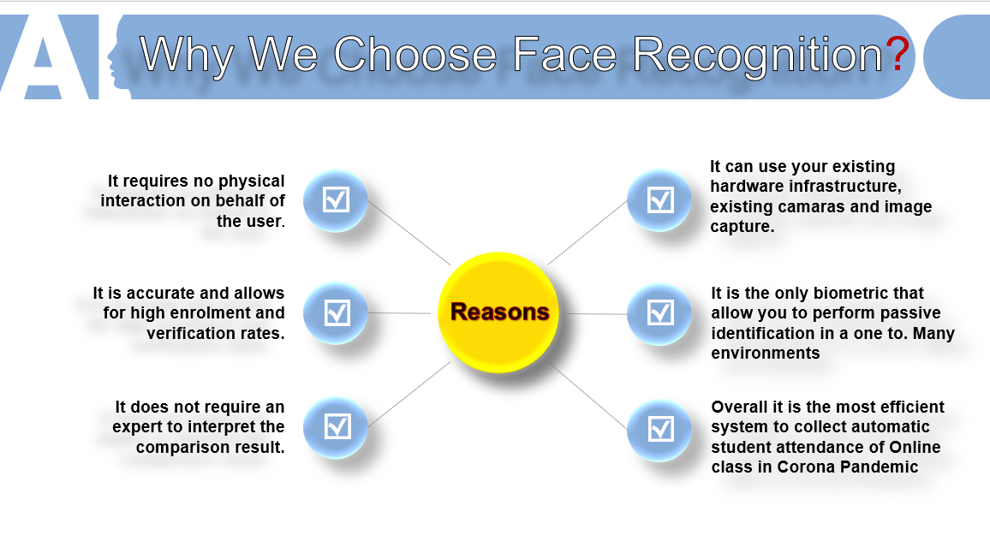

Source - SlideShare Fig 3. Why we choose Face recognition

Figure 3 outlines several reasons for choosing face recognition technology:

1. **No Physical Interaction Required**: Users do not need to interact physically with the system.

2. **High Accuracy**: The technology allows for high enrollment and verification rates.

3. **Ease of Use**: Interpretation of comparison results does not require an expert.

4. **Utilizes Existing Infrastructure**: It can use existing cameras and image capture systems.

5. **Passive Identification**: It is the only biometric that allows for passive identification in various environments.

6. **Efficiency in Online Attendance**: It is an efficient system for automatic student attendance in online classes, especially useful during the COVID-19 pandemic.

These points highlight the convenience, accuracy, and adaptability of face recognition technology.

## 1.1.3 Objectives

The primary objective of this research is to design, develop, and evaluate an OpenCV-based facial recognition attendance system integrated with intruder detection capabilities to enhance cybersecurity in corporate environments. This system aims to provide a secure, efficient, and reliable solution for managing employee attendance and preventing unauthorized access. The specific objectives of the study are outlined below:

**1. Develop a Secure and Reliable Facial Recognition System**

The objective of this project is to leverage advanced computer vision methodologies and machine learning algorithms to construct a reliable facial recognition system capable of accurately identifying authorized personnel. Key tasks include the implementation of face detection and recognition algorithms utilizing OpenCV and the `face_recognition` library, establishment of a comprehensive database containing facial encodings for all authorized individuals within the organization, and optimization of the system to effectively operate under diverse lighting conditions and accommodate various facial expressions. This initiative aims to enhance security measures by providing a robust and efficient means of personnel identification.

**2. Automate Attendance Management**

The objective of this project is to incorporate facial recognition technology into the attendance management system to automate and optimize the process, thereby minimizing manual errors and reducing administrative workload. Key tasks involve the development of an application capable of capturing facial images in real-time and comparing them against a database of authorized personnel, enabling automatic attendance recording by identifying recognized individuals. Additionally, ensuring the system's scalability to handle a large volume of employees and providing real-time updates will be prioritized, aiming to enhance efficiency and accuracy in attendance management.

**3. Implement Real-Time Intruder Detection**

The objective of this project is to bolster corporate security by implementing a real-time detection and alert system to identify unauthorized access attempts promptly. Key tasks involve developing a mechanism to distinguish between authorized and unauthorized individuals through facial recognition technology. Additionally, an alert system will be implemented to notify security personnel instantly upon detecting an intruder. Ensuring the detection system operates seamlessly in real-time, without significant latency, will be crucial to swiftly address security threats and prevent unauthorized access.

**4. Enhance Recognition Accuracy**

The objective of this initiative is to enhance the accuracy and reliability of the facial recognition system by addressing environmental and personal factors that can influence its performance. Key tasks involve implementing advanced preprocessing techniques like image normalization and data augmentation to enhance the quality of input images. Additionally, techniques such as histogram equalization will be utilized to manage variations in lighting conditions effectively. Extensive testing will be conducted to identify and mitigate common sources of errors, including occlusions and facial accessories like glasses and masks, ensuring the system's robustness across diverse scenarios.

**5. Ensure Ethical and Privacy-Compliant Deployment**

The objective of this endeavor is to implement the facial recognition system in a manner that upholds privacy standards and complies with ethical guidelines and data protection regulations. Key tasks include establishing protocols for secure storage and handling of data, safeguarding facial images and encodings from unauthorized access. Obtaining informed consent from individuals whose facial data will be utilized in the system is paramount. Transparency in the system's operation will be ensured, providing individuals with comprehensive information regarding the utilization and protection of their data. This approach aims to instill trust and confidence among users while respecting their privacy rights.

**6. Evaluate System Performance and User Acceptance**

The objective is to evaluate the efficacy, dependability, and user reception of the facial recognition attendance system, including its intruder detection functionalities. Key tasks involve conducting performance assessments to gauge metrics like recognition accuracy, false acceptance rate (FAR), and false rejection rate (FRR). Additionally, gathering user and security personnel feedback will assess the system's usability and acceptance. Analyzing the system's impact on operational efficiency and security within the corporate environment will provide insights into its overall effectiveness. This comprehensive evaluation aims to ensure that the system meets organizational requirements while addressing user needs and concerns.

**7. Address Challenges and Optimize System**

The objective is to recognize and overcome challenges encountered throughout the system's development and implementation, ensuring its suitability for real-world applications. Key tasks include investigating and mitigating issues related to fluctuations in facial appearance, such as aging and hairstyle changes. Additionally, optimizing system performance to ensure efficient operation on existing hardware is crucial. Developing contingency plans and fallback mechanisms for instances where facial recognition may fail enhances system reliability and resilience. By addressing these challenges proactively, the system can be effectively optimized for robust real-world usage.

By achieving these objectives, this research aims to provide a comprehensive solution that enhances both the operational efficiency and security of corporate environments through the integration of advanced facial recognition technology. The successful implementation of this system will demonstrate the potential of biometric solutions in addressing contemporary cybersecurity challenges and improving corporate management practices.

## 1.1.4 Significance of the study

The integration of advanced facial recognition technology with corporate security systems presents a significant leap forward in both cybersecurity and operational efficiency. This study explores the implementation of an OpenCV-based facial recognition attendance system with intruder detection capabilities, aiming to address the growing need for robust security solutions in corporate environments. The significance of this study can be understood through various dimensions:

**1. Enhancing Corporate Security**

One of the primary motivations for this study is to enhance the security framework within corporate settings. Traditional security measures are increasingly becoming inadequate against sophisticated cyber threats. By leveraging facial recognition technology, this study aims to provide a more secure and reliable method for authenticating individuals entering corporate premises. The system's real-time intruder detection capabilities further bolster security by promptly identifying and alerting security personnel about unauthorized access attempts. This proactive approach helps in preventing potential security breaches, thereby protecting sensitive corporate data and intellectual property.

**2. Improving Attendance Management**

The automation of attendance management is another significant contribution of this study. Traditional methods of tracking attendance, such as manual entry and card-based systems, are prone to errors, inefficiencies, and fraudulent activities like buddy punching. The facial recognition attendance system developed in this study automates the process, ensuring accurate and efficient recording of employee attendance. This not only reduces administrative workload but also ensures the integrity of attendance data, which is crucial for accurate payroll processing and employee management.

**3. Operational Efficiency**

The implementation of a facial recognition-based attendance system streamlines the operational processes within an organization. By automating attendance tracking and integrating it with the corporate security infrastructure, the system reduces the need for manual intervention and supervision. This leads to increased operational efficiency, allowing human resources and security personnel to focus on more strategic tasks rather than routine administrative duties. The system's ability to provide real-time data and analytics also supports better decision-making and resource allocation.

**4. Technological Advancement**

This study contributes to the technological advancement in the field of computer vision and machine learning. By developing and optimizing an OpenCV-based facial recognition system, the research provides insights into the practical application of these technologies in real-world scenarios. The study addresses various challenges, such as variations in lighting conditions, facial expressions, and occlusions, and presents solutions to enhance the accuracy and reliability of facial recognition systems. These technological contributions can be valuable for future research and development in the field.

**5. Ethical and Privacy Considerations**

While the study focuses on enhancing security and efficiency, it also addresses the ethical and privacy concerns associated with the deployment of facial recognition technology. By establishing protocols for secure data handling, obtaining informed consent, and ensuring transparency, the study promotes the responsible use of biometric data. This approach helps in building trust among employees and stakeholders, ensuring that the deployment of such technologies does not infringe on individual privacy rights. The ethical framework outlined in this study can serve as a guideline for other organizations looking to implement similar systems.

**6. Empirical Validation**

The study provides empirical validation of the proposed system through rigorous testing and evaluation. By measuring metrics such as recognition accuracy, false acceptance rate (FAR), and false rejection rate (FRR), the research demonstrates the effectiveness and reliability of the system in real-world conditions. This empirical evidence supports the feasibility of deploying facial recognition systems in corporate environments and highlights the practical benefits of such implementations.

**7. Addressing Contemporary Security Challenges**

In the context of growing cybersecurity threats, this study addresses contemporary challenges by providing an innovative solution that combines biometric authentication with real-time security monitoring. The dual functionality of the system—automating attendance management while enhancing security—makes it a comprehensive tool for modern corporate environments. The study's findings and recommendations can guide organizations in adopting advanced security technologies to protect their assets and personnel effectively.

**8. Economic Impact**

The implementation of an efficient and reliable facial recognition attendance system can have a positive economic impact on organizations. By reducing administrative costs associated with manual attendance tracking and minimizing the risk of security breaches, the system can lead to significant cost savings. Additionally, the increased operational efficiency and improved security can enhance overall productivity, contributing to the organization's financial health and competitive advantage.

In conclusion, the significance of this study lies in its comprehensive approach to addressing critical security and operational challenges in corporate environments. By integrating advanced facial recognition technology with attendance management and intruder detection, the study provides a robust, efficient, and ethical solution that can significantly enhance corporate security and operational efficiency. The insights and solutions presented in this research have the potential to influence future developments in the field and guide organizations in adopting advanced security technologies.

## **1.1.5 Outline of The Study**

This section provides an overview of the structure and organization of the research paper, outlining the key components and chapters that constitute the study. The outline is designed to guide readers through the various stages of the research process and highlight the contributions and findings of each section.

The research paper is structured into seven chapters, each addressing a different aspect of the study on facial recognition technology for corporate security and attendance management systems.

**Chapter 1: Introduction** provides the background of the study, focusing on the evolution of cybersecurity in corporate environments and the role of facial recognition technology. It identifies the problems addressed, such as the inadequacies of traditional security and attendance systems, and outlines the study's objectives, including developing a facial recognition attendance system and intruder detection capabilities. The chapter also discusses the significance of the study in enhancing corporate security and operational efficiency, and provides an outline of the paper's structure.

**Chapter 2: Literature Review** offers an overview of existing literature on cybersecurity trends, challenges, and solutions in corporate settings. It explores biometric authentication and facial recognition technology, detailing their principles, applications, and advancements. The chapter also surveys the integration of facial recognition with attendance systems, highlighting benefits, challenges, and best practices, and examines ethical and privacy considerations associated with deploying such systems, discussing relevant guidelines and regulations.

**Chapter 3: Methodology** describes the research approach and methodology, including system design, data collection, and evaluation methods. It presents the architecture and components of the facial recognition attendance system, detailing the algorithms, libraries, and technologies used. The chapter explains the process of collecting and preprocessing facial images to create a dataset for training and testing, and provides technical details of the system implementation, including code snippets, configurations, and dependencies.

**Chapter 4: Results** presents the testing and evaluation results of the facial recognition attendance system, analyzing performance metrics such as true positive rate, false positive rate, and overall system accuracy. The chapter also summarizes feedback from users and stakeholders regarding the system's usability, reliability, and acceptance.

**Chapter 5: Discussion** interprets the study findings in relation to the research objectives, discussing their broader implications for corporate security and operational management. It identifies challenges encountered during the research process and discusses the system's limitations. The chapter also proposes areas for further research and development to address these limitations and improve system performance.

**Chapter 6: Conclusion** summarizes the key findings of the study, emphasizing its contributions to the fields of cybersecurity and operational management. It discusses the implications of the research for practice, policy, and future developments, and provides concluding remarks on the study's significance and potential impact on corporate security and operational efficiency.

**Chapter 7: References** lists all references cited throughout the research paper, following a standardized citation format.

This outline provides a structured framework for the research paper, guiding readers through the research process from background and literature review to methodology, results, and conclusion. Each chapter contributes to a comprehensive understanding of the study's objectives, findings, and implications, culminating in a cohesive analysis of the facial recognition attendance system and its significance for corporate security and operational management.

## **1.1.6 Motivation:**

- **Old-Fashioned Attendance is a Hassle:** The way we usually mark attendance (with signatures or cards) is outdated and causes mistakes. It's not suitable for the flexible work styles we have nowadays.

The reason we're doing this project is that the usual way of marking attendance is kind of a hassle. Think about signing in or using cards – it takes time, and sometimes people make mistakes. We need a more modern system that fits how we work today.

- **Cybersecurity Threats are Real:** There are more and more bad people trying to hack into our work systems. The old attendance systems are not very good at keeping these bad people out, and that puts our important work information at risk.

With more people trying to hack into our work systems, we need to make sure our attendance system is not an easy target. The old systems might not be good enough, so we're working on a new system that's better at keeping our work information safe.

- **Everyone is Working from Different Places**: Lots of people are working from home or different places. Our attendance system needs to be smart enough to keep track of everyone, whether they're in the office or somewhere else.

Nowadays, not everyone works in the office. Some people work from home or other places. Our new system should be able to keep track of everyone, no matter where they are, making sure we have the right attendance information.

- **We Want Things to be Easier and Less Mistake-Prone:** Keeping attendance should be easy and not cause problems. With our new system, we're trying to make things smoother by using facial recognition. It's like taking a quick picture, and it helps avoid mistakes that can happen when people have to write things down.

We want to keep attendance simple and avoid mistakes. The new system uses facial recognition – it's like taking a quick picture of your face. This way, we can make sure everything is correct without people having to write things down, making things easier for everyone.

# **1.2 Literature review**

| **Model Name** | **Pros** | **Cons** |
| --- | --- | --- |
| [Implementation of Low Cost IoT Based Intruder Detection System by Face Recognition using Machine Learning](https://turcomat.org/index.php/turkbilmat/article/view/8295) | * **Cost-Effective: Utilizes affordable components like Raspberry Pi, reducing setup and ownership costs** * **Real-Time Processing: Capable of processing data in real time, which is crucial for immediate detection and response** | * **Privacy Concerns: Capturing and storing facial data can raise privacy issues and potential misuse** * **Vulnerability to Evasion: Like all security systems, it can potentially be evaded or fooled with sophisticated techniques** |
| [Smart Attendance System using OPENCV based on Facial Recognition](https://pdfs.semanticscholar.org/c38c/43363313ecf6f70ac3194de711a861503e76.pdf) | * **Automatic Spreadsheet Management** * **PDF Report Generation** * **Adaptive Training Database** | * **Limited to Authorized Students** * **Challenges in Crowded Environments** |
| [Facial Recognition Attendance System Using Python and OpenCv](https://d1wqtxts1xzle7.cloudfront.net/81503865/D05021829-libre.pdf?1646134399=&response-content-disposition=inline%3B+filename%3DFacial_Recognition_Attendance_System_Usi.pdf&Expires=1708772402&Signature=QOQacHMnG98RruhgEN30oaf-4JMRhMIASyTbhvPuA~Q~x7452w9fsZAWzy6LkBh7aF2J4ScPsTjl~BBJo2gvsihIyTJZjHMsKFRndYvlgGTXgZamqkB2Fq2pjqF7ZFUcMknC4ZoR7~hZ3F6NWyK-ip-gjvaJzUYxzi51dk0g8jqQA4rJ59VhPZCjPEtEIS1YRKNqcc9Kwr6zmQXZMqqVLV-vnThEf5a~dq64-ALKC4Q3~JnqehP1VKHc8YGdCo7kgyzrq65mrcEcmox1qc1JLRQmJcFiiq94K51-mM7wCGkrIFCuTMnQ4Z9dMURw1e6kAa-pNYiVkEnhXulViS2Waw__&Key-Pair-Id=APKAJLOHF5GGSLRBV4ZA) | * **Enhanced Accuracy: The Facial Recognition Attendance System offers improved accuracy in attendance tracking by utilizing face recognition technology.** | * **Limited Scope for Identity Changes: The reliance on facial features for identity verification may pose challenges in scenarios where individuals undergo significant changes in their appearance, such as surgeries or injuries.** |

Table 1. Comparison of Face Recognition Systems for Various Applications

Table 1 summarizes various facial recognition systems, highlighting their pros and cons. The "Implementation of Low-Cost IoT Based Intruder Detection System by Face Recognition using Machine Learning" is noted for its cost-effectiveness and real-time processing capabilities, but it raises privacy concerns and is vulnerable to evasion. The "Smart Attendance System using OPENCV based on Facial Recognition" offers automatic spreadsheet management, PDF report generation, and an adaptive training database, though it is limited to authorized students and faces challenges in crowded environments. The "Facial Recognition Attendance System Using Python and OpenCv" provides enhanced accuracy but has a limited scope for identity changes, posing challenges when individuals undergo significant changes in appearance.

Abhishek et al. proposed , "ClassRoom Attendance System Using

Facial Recognition System," discusses the development of an automated attendance system using advanced facial recognition technology. Traditional 2D face recognition methods often struggle with accuracy due to variations in lighting, expressions, and angles. To address these challenges, the paper proposes the use of 3D facial models, which capture the geometric structure of the face, thereby improving identification reliability. The system aims to automate attendance tracking in classrooms, enhancing efficiency and accuracy without manual intervention. This approach underscores the significant advancements in biometric recognition technologies, particularly in image processing and pattern recognition, highlighting their potential to improve organizational performance and decision-making. The paper emphasizes the importance of continued research in this field to overcome existing limitations and achieve reliable automatic human recognition, reflecting the growing interest and numerous research efforts dedicated to facial recognition technology. [1]

Gang hua et. al introduced "Introduction to the special section on real-world face recognition," published in IEEE Transactions on Pattern Analysis and Machine Intelligence, addresses the complexities of applying face recognition technology in real-world scenarios. The motivation for this special section is to advance the field by promoting systematic research and evaluation of robust methods that can handle real-world challenges, such as uncontrolled lighting, facial expressions, and occlusions. The paper outlines the review process for the submissions, highlighting the rigorous selection of 38 out of 42 original contributions. It covers various aspects of face recognition, including robust feature design, clustering algorithms, user interaction models, and applications in web and public security. The paper emphasizes the ongoing scientific challenges and the need for further improvements in both controlled and uncontrolled environments. It also discusses the misconception that face recognition is either a solved problem or too difficult to address, advocating for continued research to bridge the gap between current capabilities and practical real-world applications. The importance of user interface design and leveraging additional contextual information to enhance face recognition systems is also highlighted.[2]

F. P. Filippidou et. al proposed The research paper "Single Sample Face Recognition Using Convolutional Neural Networks for Automated Attendance Systems," published by IEEE, explores the application of Convolutional Neural Networks (CNNs) for face recognition in scenarios with limited training data, specifically focusing on the challenge of recognizing faces with only a single sample per person. The authors address the problem of the vast data requirements for training deep CNNs by employing a two-phase method that combines data augmentation and transfer learning, which involves fine-tuning pre-trained CNN models. The study evaluates five well-known pre-trained CNNs and finds that DenseNet121 is the most effective and robust model, achieving up to 99% top-1 accuracy in this context. This research aims to develop a real-time visual-based attendance system capable of accurately recognizing individuals from minimal training data. The paper provides experimental results that demonstrate the efficacy of DenseNet121 for single sample per person face recognition tasks, highlighting its potential for practical applications in automated attendance systems.[3]

M. G. M. Johar et. al introduced The research paper titled "Student's Activity Management System Using QR Code and C4.5 Algorithm" discusses the development of a web-based system designed to manage and track student activities at Management & Science University (MSU). This system leverages the Laravel framework with PHP for its development. The primary goal is to predict students' soft skills achievements as outlined in the Graduate Employability Skills (GEmS) framework by analyzing the activities students participate in during their studies. The C4.5 algorithm, a decision tree algorithm in data mining, is integrated to forecast these achievements based on the students' activity data. Additionally, the system helps in managing and organizing student activities each semester, ensuring that students can efficiently plan and prioritize their engagements. The inclusion of QR codes facilitates the validation and tracking of student participation in these activities. This feature allows lecturers to control and monitor the number of students involved in various activities, thereby improving the overall management and effectiveness of student activity tracking and soft skills assessment.[4]

F. Masalha et. al proposed The research paper titled "A Students Attendance System Using QR Code" describes a method to streamline and improve the attendance-taking process in university settings by leveraging the widespread use of smartphones among students. The proposed system involves displaying a QR code during or at the beginning of each lecture, which students scan with their smartphones to confirm their attendance. This approach aims to save valuable lecturing time and enhance the educational process by making attendance tracking more efficient. The paper provides high-level implementation details of the system, focusing on how it verifies student identity to prevent false registrations and ensure the accuracy of attendance records. The system's reliance on modern smartphone technology capitalizes on the familiarity and preference of students for these devices, making the process intuitive and quick.[5]

O. Arulogun et. al proposed The research paper titled "RFID-Based Students Attendance Management System" explores the use of Radio Frequency Identification (RFID) technology to address the challenges of monitoring student attendance in educational institutions, particularly in developing countries. The authors propose a system that employs RFID tags and readers to automate the attendance process, thereby eliminating the time-consuming and error-prone manual methods traditionally used. This system enhances efficiency by allowing automatic, wireless identification of students as they enter the classroom, facilitating real-time attendance tracking. Additionally, it provides educational administrators with accurate classroom attendance data, which can be used for allocating attendance scores and making informed managerial decisions. The study underscores the potential of RFID technology to improve administrative processes and educational management by offering a reliable and swift method for recording student attendance. [6]

F. Silva et. al proposed The research paper titled "Automatic Control of Students' Attendance in Classrooms Using RFID" by Francisco Silva, Víctor Filipe, and António Pereira, published by IEEE, discusses the implementation of an RFID-based system to automate the attendance process in educational institutions. The paper highlights the widespread interest and ongoing research in RFID technology due to its potential applications in various domains, including security and privacy concerns. The authors propose a system architecture and prototype that utilizes distributed RFID over Ethernet to streamline the attendance registration process. This approach aims to replace the manual, time-consuming methods traditionally used, thereby enhancing efficiency and accuracy in tracking student attendance. The paper demonstrates how the deployment of RFID technology can address common operational issues in universities by providing a reliable and automated solution for attendance management. The study underscores the practical benefits of integrating RFID systems into educational settings, showcasing the technology's ability to solve everyday problems related to attendance tracking. [7]

M. Karunakar et. al proposed The research paper "Smart Attendance Monitoring System (SAMS): A Face Recognition Based Attendance System for Classroom Environment" by Shubhobrata Bhattacharya, Gowtham Sandeep Nainala, Prosenjit Das, and Aurobinda Routray, published by IEEE, presents an innovative solution for automating student attendance using face recognition technology. Traditional methods of recording attendance, such as calling names or signing sheets, are time-consuming and prone to errors or fraud. The proposed system addresses these issues by utilizing ubiquitous components to develop a portable device capable of automatically managing attendance in real-time. This system aims to enhance the accuracy and efficiency of attendance tracking, thereby improving the overall assessment and quality monitoring processes within academic institutions. The integration of face recognition technology ensures data reliability and convenience, marking a significant advancement over conventional attendance methods. [8]

S. Wenhui et. al The paper "Multi-view face recognition using deep neural networks" by Feng Zhao, Jing Li, Lu Zhang, Zhe Li, and Sang-Gyun Na introduces a face recognition algorithm designed to enhance accuracy across multiple views using deep neural networks. The proposed system utilizes convolutional neural networks (CNNs) to extract facial features, Principal Component Analysis (PCA) for dimensionality reduction, and Bayesian theory for similarity judgment. This method addresses various challenges like different face angles and expressions, aiming to improve recognition reliability. The system achieves a 98.52% recognition accuracy on the CAS-PEAL dataset, demonstrating robustness against face presentation attacks, such as printed images or video replays, making it suitable for applications in smart surveillance, online payment, and access control systems.[9]

A. S. Al-Waisy et. al The research paper "A Robust Face Recognition System Based on Curvelet and Fractal Dimension Transforms" introduces a powerful face recognition system designed for authentication and identification tasks, proposing a new facial feature extraction approach. The system comprises four stages: preprocessing using a sigmoid function to standardize intensity dynamic range, face detection based on the Viola-Jones algorithm, feature extraction combining the Digital Curvelet via wrapping transform and Fractal Dimension transform, and recognition utilizing K-Nearest Neighbor (KNN) and Correlation Coefficient (CC) Classifiers. Experimental evaluation on three diverse datasets, SDUMLA-HMT, Faces96, and UMIST, demonstrates the robustness and effectiveness of the proposed approach for both authentication and identification tasks compared to established methods. The paper addresses the growing demand for alternative identity authentication methods in response to increased hacking and forgery techniques, highlighting the advantages of biometric-based systems like face recognition in terms of security, convenience, and user-friendliness.[10]

A. Fassio et. al The research paper presents LUNA, a Python 3 toolkit designed to enhance machine learning-based drug discovery by introducing new hashed fingerprints that encode protein-ligand interactions. Traditional molecular fingerprints often lack protein information and structural context, hindering model interpretability. LUNA proposes Extended Interaction FingerPrint (EIFP), Functional Interaction FingerPrint (FIFP), and Hybrid Interaction FingerPrint (HIFP) as new fingerprints, along with visual strategies for interpretability. The study conducted three major experiments: training machine learning models to replicate DOCK3.7 scores using 1 million docked Dopamine D4 complexes, showcasing EIFP-4,096's superior performance (R2 = 0.61); supporting interpretable machine learning models with LUNA; and demonstrating the ability of interaction fingerprints to identify similarities across molecular complexes that other fingerprints overlook. The authors envision LUNA and its interface fingerprints as promising tools for machine learning-based virtual screening campaigns, offering improved interpretability and accuracy in drug discovery. LUNA is freely available at Github.[11]

Y. Jiang et. al The research paper introduces the concept of space debris fingerprints as a means to address the increasing threat posed by space debris to human space activities. It emphasizes the necessity of defining these fingerprints and identifying different debris characteristics based on them. The definition of debris fingerprints relies on data from ground-based and space-based observation systems such as cameras, radars, and laser ranging. The paper outlines the creation of a space debris fingerprint identification technology aimed at verifying debris identity, utilizing both global and local features. Global features encompass easily identifiable characteristics like track inclination, height, size, volume, shape cusp features, and the number of fingerprint lines. Local features include the position, direction, curvature, area, and other attributes of non-smooth points, bifurcation points, fractures, and zigzags in space debris fragments.[12]

A. B. V. Wyzykowski et. al The research paper presents a novel hybrid approach for synthesizing realistic, multiresolution, and multisensor fingerprints to address the discontinuation of public access to existing high-resolution fingerprint databases and the absence of hybrid databases containing fingerprints from different sensors with varying resolutions. The approach involves enhancing Anguli, a handcrafted fingerprint generator, to create pores, scratches, and dynamic ridge maps, which are then converted into realistic fingerprints using CycleGAN to add textures to the images. Unlike other neural network-based methods, this approach generates multiple images with different resolutions and styles for the same identity. The authors built a synthetic database comprising 14,800 fingerprints using their method and conducted fingerprint recognition experiments with pore- and minutiae-based matching techniques, along with various fingerprint quality analyses, to confirm the similarity between real and synthetic databases. Additionally, a human classification analysis was performed, revealing that volunteers could not distinguish between authentic and synthetic fingerprints. These experiments validate the suitability of the authors' approach for supporting further fingerprint recognition studies in the absence of real databases.[13]

W. Chunming et. al The research paper introduces YOLOv4, a state-of-the-art object detection model that achieves optimal speed and accuracy through the integration of various features designed to improve Convolutional Neural Network (CNN) performance. These features include Weighted-Residual-Connections (WRC), Cross-Stage-Partial-connections (CSP), Cross mini-Batch Normalization (CmBN), Self-adversarial-training (SAT), and Mish activation, among others. By combining these features and introducing new techniques such as Mosaic data augmentation, DropBlock regularization, and CIoU loss, the YOLOv4 model achieves outstanding results, including 43.5% Average Precision (AP) and 65.7% AP50 for the MS COCO dataset, all while maintaining a real-time speed of approximately 65 frames per second (FPS) on Tesla V100 GPUs. The paper provides theoretical justification for the effectiveness of these features and offers the source code for further exploration and implementation.[14]

S. Pawar et. al The research paper provides a comprehensive survey of Local Binary Patterns (LBP), a nonparametric descriptor widely used in image processing and computer vision to efficiently summarize local image structures. LBP has garnered increasing interest in recent years and has proven effective in various applications, particularly in facial image analysis, including tasks such as face detection, recognition, expression analysis, and demographic classification. The paper covers the methodology of LBP and its recent variations, highlighting its successful applications in facial image analysis. It discusses the tolerance of LBP to illumination changes and its computational simplicity, emphasizing its versatility across different domains of image analysis. Published in IEEE Transactions on Systems, Man, and Cybernetics, the paper serves as a valuable resource for researchers and practitioners interested in understanding and utilizing LBP-based techniques.[15]

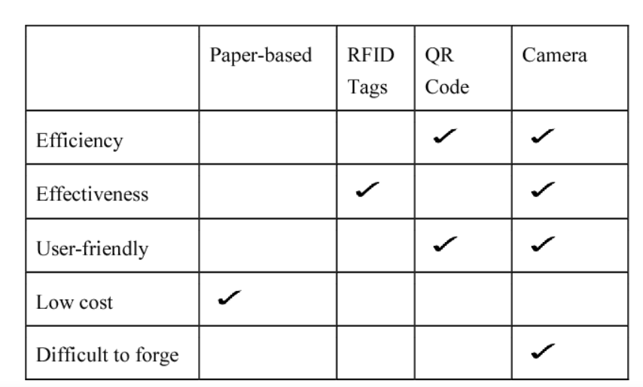 Table 2. Comparison of Identification Methods Based on Key Criteria

Table 2 compares different identification methods—Paper-based, RFID Tags, QR Code, and Camera—across several criteria: Efficiency, Effectiveness, User-friendliness, Low Cost, and Difficulty to Forge. The QR Code and Camera methods are noted for their efficiency. RFID Tags, QR Code, and Camera methods are considered effective. In terms of user-friendliness, QR Code and Camera methods are highlighted. Paper-based methods are marked as low-cost. QR Code and Camera methods are deemed difficult to forge. This comparison emphasizes the strengths and weaknesses of each identification method based on these key criteria.

# **1.3 Definitions**

**Definitions**

1. **Artificial Intelligence (AI)**: The simulation of human intelligence processes by machines, especially computer systems. Specific applications of AI include expert systems, natural language processing, speech recognition, and machine vision.

1. **Biometric Authentication** : A security process that relies on the unique biological characteristics of an individual to verify their identity. Examples include fingerprint recognition, facial recognition, and iris scanning.

1. **Computer Vision (CV)** : A field of artificial intelligence that enables computers to interpret and make decisions based on visual data from the world, such as images or video footage.

1. **Facial Recognition** : A technology capable of identifying or verifying a person from a digital image or a video frame. It works by comparing selected facial features from the image and a database.

1. **Intruder Detection** : A security mechanism designed to detect unauthorized access to a system or premises. In the context of facial recognition systems, it refers to identifying individuals who are not authorized to enter a secured area.

1. **OpenCV** : Open Source Computer Vision Library, an open-source computer vision and machine learning software library. OpenCV was designed for computational efficiency and with a strong focus on real-time applications.

1. **Face Encodings** : Numerical representations of the unique features of a face. In facial recognition systems, these encodings are used to compare and match faces.

1. **Real-Time Processing** : The capability of a system to process data and provide output almost instantaneously. In the context of facial recognition, it refers to the system's ability to recognize faces and detect intruders in real-time, as the events occur.

1. **Attendance Tracking System** : A system used to record the attendance of individuals, often used in workplaces, schools, and other organizations. An automated system can improve accuracy and efficiency.

1. **Region of Interest (ROI)** : A selected subset of samples within a dataset identified for a particular purpose. In image processing, it refers to a portion of an image that is the focus of analysis.

1. **Comma-Separated Values (CSV)** : A file format used to store tabular data, such as a spreadsheet or database. Each line in a CSV file is a data record, and each record consists of one or more fields separated by commas.

1. **Frames Per Second (FPS)** : A measure of how many images (frames) a camera can capture or a display can show per second. Higher FPS results in smoother motion representation in videos.

1. **Machine Learning (ML)** : A subset of artificial intelligence that involves training algorithms to learn from and make predictions based on data. ML is essential for developing systems that improve their performance over time.

1. **Red, Green, Blue (RGB)** : A color model used in digital imaging, where colors are represented as combinations of red, green, and blue light.
2. **Support Vector Machine (SVM)** : A supervised machine learning model used for classification and regression analysis. It works by finding the hyperplane that best separates the classes in the feature space.
3. **Real-Time Streaming Protocol (RTSP)** : A network control protocol designed for use in entertainment and communications systems to control streaming media servers. RTSP is used for establishing and controlling media sessions between endpoint

**Chapter 2. Dataset**

In this project, the dataset is the most crucial element, as we are building a Face Recognition attendance system using OpenCV with intruder detection. It is a set of facial images that the system uses to learn which members of your queue are authorized to gain access, and which are not. In this section, I will work on collecting, cleaning the data and performing EDA on the dataset.

# **2.1 Collection**

The collection process involves gathering high-quality images of all authorized personnel. The primary goal is to ensure each individual has multiple images captured under various conditions to improve the robustness of the facial recognition system. Key aspects of the collection process include:

## **2.1.1 Image Quality:**

* Ensure that the images are high-resolution and well-lit to capture clear facial features.
* Capture multiple images of each individual from different angles and with varying facial expressions to enhance the system's ability to recognize faces accurately

## **2.1.2 Naming Convention:**

* Name each image file according to the individual's name or a unique identifier. This helps in associating the face encodings with the correct identities.
* Example filenames: aman.jpg , priyanshu.png

## **2.1.3 Storage Structure**

* Store the images in a directory structure that is easy to access programmatically. For instance, images can be stored in a folder named student_images.

Mathematically, for an image 𝑖 ∈ 𝐼(norm), the encoding 𝑒 ∈ 𝐸 is obtained through the function g(i). Each encoding e represents the unique facial features of an individual.

# **2.2 Exploratory Data Analysis (EDA)**

EDA involves analyzing the dataset to summarize its main characteristics and gain insights that can help improve the system's performance. Key steps in EDA include:

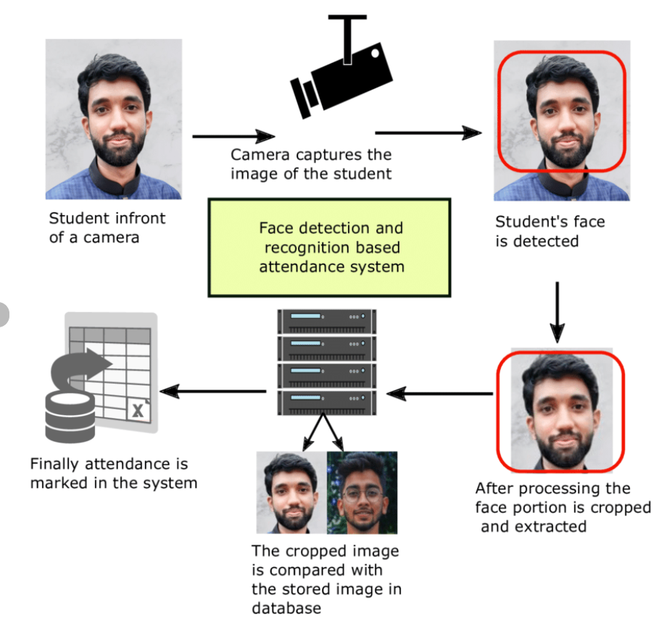Source - Research Gate Fig 4. Workflow of a Facial Recognition-Based Attendance System

Figure 4 illustrates the process of a **facial recognition-based attendance system**. Let’s break it down:

1. **Image Capture**: The system begins with an image of a student standing in front of a camera. The camera captures the student’s face.
2. **Recognition and Detection**: The system identifies that a face is present and suitable for processing. It then proceeds to the next step.
3. **Face Processing**: The captured face image is processed and cropped from the original frame. This step ensures that only the face region is considered for further analysis.
4. **Database Comparison**: The cropped face image is compared with stored images in the system’s database. The goal is to find a match and confirm the student’s identity.
5. **Attendance Marking**: If a match is found, the system marks the student’s attendance. This automation streamlines the attendance process, making it efficient and accurate.

## **2.2.1. Summary Statistics:**

- Calculate basic statistics such as the number of images per individual, distribution of image resolutions, and average image dimensions.

Let $n_{p}$ be the number of images for person p $ϵ$ P. The total number of images N is given by:

N = $\sum_{pϵP}{}$ $n_{p}$

## **2.2.2. Visualization:**

- Visualize the dataset to understand its structure and distribution. Common visualizations include histograms of image dimensions and bar charts of the number of images per individual.

For image dimensions, let $ω$ (i) and h(i) are the width and height of the image i $ϵ$ I . The distribution of widths and heights can be represented as:

{ $ω$ (i) | i $ϵ$ I } and{ h(i) | i $ϵ$ I }

## **2.2.3. Anomaly Detection:**

- Identify and handle anomalies such as low-quality images or incorrect file naming. This ensures the dataset's integrity and reliability.

Anomalies can be detected by checking for images that do not meet predefined quality criteria, such as minimum resolution or proper lighting conditions. Let Q(i) be a quality function that returns true if the image i meets the criteria, and false otherwise.

By systematically collecting, preprocessing, and analyzing the dataset, we can ensure the facial recognition system is robust, accurate, and reliable. The quality and comprehensiveness of the dataset are critical to the overall success of the system.

**Chapter 3. Case Study**

# **3.1 Introduction to Case Study**

In the contemporary landscape of corporate security and operational management, the integration of advanced technologies has become imperative to address evolving challenges effectively. This case study centers on a medium-sized technology company navigating through security vulnerabilities and inefficiencies in traditional attendance tracking methods. As the company seeks to fortify its security measures and streamline administrative processes, the adoption of facial recognition technology emerges as a promising solution.

The company operates within a dynamic industry, where safeguarding sensitive data, protecting intellectual property, and ensuring the safety of employees are paramount concerns. However, reliance on conventional security mechanisms, such as access cards and manual attendance registers, has proven inadequate in addressing emerging threats and operational inefficiencies. Instances of unauthorized access, payroll discrepancies, and compliance issues have underscored the need for a transformative approach to security and attendance management.

Motivated by the imperative to enhance its security posture and optimize operational workflows, the company embarks on a journey to explore the potential of facial recognition technology. By leveraging cutting-edge advancements in computer vision and machine learning, the company aims to develop a robust facial recognition attendance system that not only enhances security measures but also streamlines attendance tracking processes.

Through this case study, we delve into the company's challenges, aspirations, and strategic initiatives to deploy facial recognition technology effectively. By examining the intricacies of the company's security landscape and operational dynamics, we gain insights into the motivations driving the adoption of facial recognition technology and the anticipated benefits for the organization.

Ultimately, this case study serves as a testament to the transformative power of technology in addressing contemporary challenges in corporate security and operational management. By embracing innovation and embracing a proactive approach to security, the company endeavors to chart a path toward enhanced resilience, efficiency, and stakeholder trust in an ever-evolving digital landscape.

# **3.2 Challenges and Drawbacks**

**1. Security Vulnerabilities with Traditional Methods:**

**Challenge:** The company's reliance on conventional security measures, such as access cards and manual attendance registers, exposes it to various security vulnerabilities.

**Drawbacks:** Instances of unauthorized access, stemming from theft, duplication, or misuse of access cards, pose a significant risk to the integrity of sensitive corporate data and assets. Moreover, the lack of stringent authentication measures increases the likelihood of security breaches, thereby jeopardizing the company's reputation and operational continuity.

**2. Inefficiencies in Attendance Management:**

**Challenge:** Manual attendance tracking processes, characterized by paper-based registers and cumbersome data entry procedures, are fraught with inefficiencies and prone to human error.

**Drawbacks:** The labor-intensive nature of manual attendance management not only consumes valuable administrative resources but also introduces inaccuracies and inconsistencies in attendance records. Consequently, payroll discrepancies and compliance issues emerge as persistent challenges, undermining the company's operational efficiency and regulatory compliance efforts.

**3. Lack of Real-Time Security Monitoring:**

**Challenge:** The absence of real-time security monitoring capabilities leaves the company ill-equipped to detect and respond swiftly to security incidents or unauthorized access attempts.

**Drawbacks:** Delays in identifying intruders or suspicious activities impede the company's ability to mount effective responses, thereby exacerbating the potential impact of security breaches. Moreover, the reactive nature of incident response measures heightens the risk of data breaches, financial losses, and reputational damage, further underscoring the urgency of implementing proactive security measures.

**4. Ethical and Privacy Concerns:**

**Challenge:** The deployment of facial recognition technology raises ethical and privacy concerns among employees and stakeholders regarding the collection, storage, and use of biometric data.

**Drawbacks:** Inadequate safeguards to address these concerns may engender mistrust, resistance, or legal challenges from employees and advocacy groups. Failure to uphold stringent data protection standards and respect individual privacy rights may not only erode employee morale and engagement but also expose the company to regulatory fines, litigation, and reputational harm.

**5. Technical Limitations of Facial Recognition Systems:**

**Challenge:** Facial recognition systems are susceptible to technical limitations, such as variations in lighting conditions, facial expressions, and occlusions, which can impede recognition accuracy.

**Drawbacks:** Inaccurate or unreliable recognition results undermine user confidence in the system and diminish its effectiveness in enhancing security and operational efficiency. Furthermore, the risk of false positives or false negatives may lead to instances of misidentification, thereby compromising access control measures and eroding trust in the technology.

**Conclusion:**

The challenges and drawbacks outlined above underscore the complexity of implementing facial recognition technology in corporate environments. Addressing these challenges requires a multi-faceted approach encompassing technological innovation, policy development, and stakeholder engagement. By proactively addressing these issues, the company can pave the way for a successful deployment of facial recognition technology, leading to enhanced security, operational efficiency, and stakeholder trust.

**Chapter 4. Model Selection**

# **4.1 Methodology Overview**

The methodology for model selection in the context of the facial recognition attendance system involves a systematic approach encompassing requirement analysis, exploration of deep learning (DL) techniques, architectural design, and evaluation criteria establishment. Mathematical expressions are utilized where necessary to provide clarity on the underlying principles.

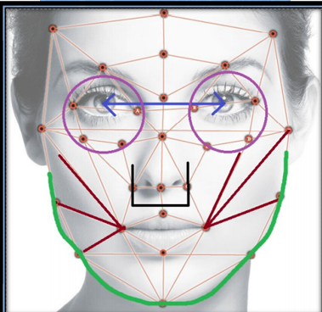

Source - Kaggle Fig 5. Detailed Facial Analysis with Annotations for Recognition and Detection

Figure 5 illustrates a face with an overlaid geometric grid, highlighting key facial landmarks connected by lines. Additional colored annotations emphasize specific facial features: purple circles around the eyes with an arrow indicating the distance between them, black lines outlining the nose, red lines accentuating the jawline and cheekbones, and a green line tracing the lower contour of the face. These annotations suggest a detailed facial analysis for recognition or detection purposes, likely for applications in security, biometrics, or facial recognition technology.

## **4.1.1. Requirement Analysis:**

The first step involves understanding the specific requirements of the facial recognition attendance system. Key considerations include:

Accuracy: The system must accurately recognize individuals to ensure reliable attendance tracking.

Speed: Real-time or near-real-time processing may be required for efficient attendance management.

Robustness: The system should be resilient to variations in lighting, facial expressions, and occlusions.

Scalability: The model should be scalable to accommodate a growing number of users and accommodate future expansions.

Compatibility: Integration with existing infrastructure and software systems should be seamless.

## **4.1.2. Exploration of DL Techniques:**

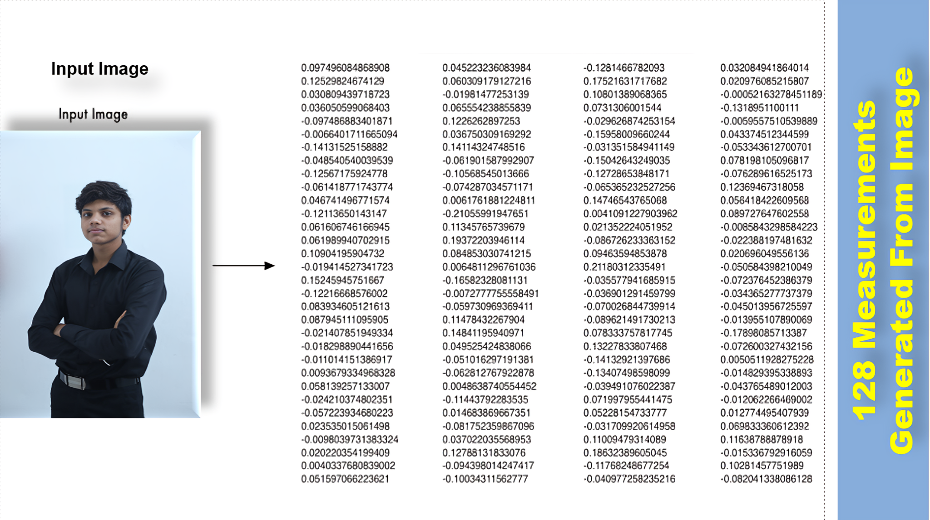

Fig 6. Input Photo and Corresponding 128-Point Facial Feature Data for Digital Face Representation

Figure 6 represents an input photo of me on the left and a set of numerical data on the right. The data consists of 128 measurements generated from the input image, likely representing facial feature points or embeddings extracted using facial recognition algorithms. These measurements are used to create a unique digital representation of the person's face for identification or analysis purposes. The text on the right emphasizes that these 128 measurements are derived directly from the input image.

Various DL techniques are explored to identify the most suitable approach for facial recognition. These may include:

Convolutional Neural Networks (CNNs): CNNs excel in image recognition tasks by automatically learning hierarchical features from input images.

Mathematical Expression (Convolution Operation):

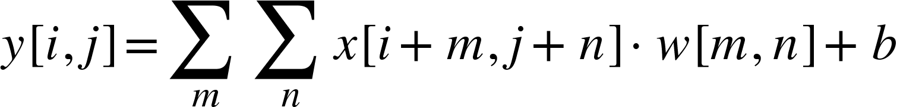

where:

-  represents the input image patch centered at location .

- denotes the convolutional filter weights.

- is the bias term.

-  is the output feature map pixel at location .

- **Siamese Networks**: Siamese networks learn embeddings of pairs of images to measure their similarity.

Mathematical Expression (Contrastive Loss):

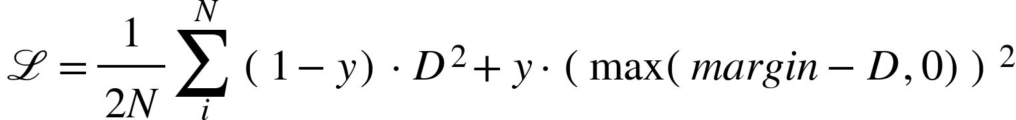

where:

-  is the number of pairs.

-  is the binary label indicating whether the pair is similar (1) or dissimilar (0).

-  is the Euclidean distance between the embeddings of the pair.

-  is the loss function.

-  is a hyperparameter controlling the separation margin between similar and dissimilar pairs.

- **Deep Metric Learning**: Deep metric learning techniques aim to learn embeddings that preserve semantic similarity between data points.

Mathematical Expression (Triplet Loss):

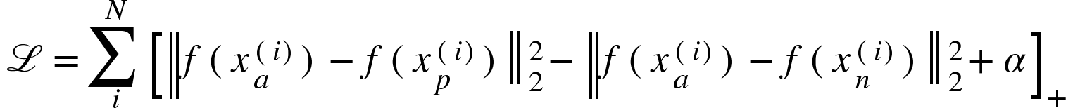

where:

- ( ), () , and ( $x_{n}^{(i)}$) are the anchor, positive, and negative samples, respectively, for the ( i ) triplet.

-  denotes the embedding function.

-  is a margin hyperparameter.

-  denotes the hinge loss.

## **4.1.3. Architectural Design:**

Based on the requirement analysis and exploration of DL techniques, a suitable model architecture is designed. This may involve:

- Selecting the number and type of layers (convolutional, pooling, fully connected) based on the complexity of the task and computational resources available.

- Incorporating regularization techniques such as dropout or batch normalization to improve generalization.

- Experimenting with different activation functions (ReLU, Leaky ReLU, etc.) to enhance model expressiveness.

## **4.1.4. Evaluation Criteria Establishment:**

Before implementing the model, evaluation criteria are established to assess its performance. These criteria may include:

• **Accuracy:** The proportion of correctly identified individuals.

• **Precision:** The proportion of correctly identified individuals among those predicted to be positive.

• **Recall:** The proportion of actual positives that were correctly identified.

• **F1-score:** The harmonic mean of precision and recall.

By following this methodology, the facial recognition attendance system can be effectively designed and implemented, meeting the requirements and achieving the desired performance metrics.

# **4.2 Model Building**

Model building for the facial recognition attendance system is a crucial step in the development process, requiring a meticulous approach to ensure accuracy, reliability, and efficiency. This comprehensive process encompasses data preprocessing, model architecture design, training, and evaluation, each playing a pivotal role in the creation of a robust and effective system.

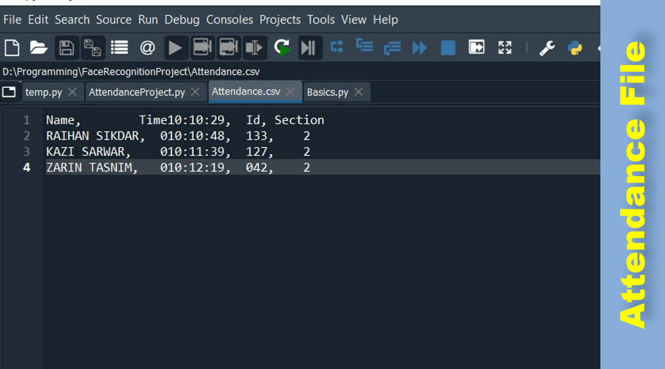

Fig 7. Attendance_sheet.csv

Figure 7 shows how the data is stored in the csv file after the object detection and attendance marked

**1. Data Preprocessing:**

Before delving into model construction, the facial image dataset undergoes a series of preprocessing steps aimed at enhancing its quality and suitability for training. This preparatory phase involves normalization, resizing, and augmentation techniques.

Normalization involves scaling pixel values to a standardized range, typically between 0 and 1 or -1 and 1, to facilitate convergence during training and improve numerical stability. This process ensures that all input data are on a similar scale, preventing certain features from dominating the learning process due to differences in magnitude.

Resizing is employed to standardize the dimensions of facial images, ensuring uniformity and reducing computational complexity during training. Techniques such as bilinear interpolation are used to interpolate pixel values when resizing images to a consistent size, maintaining image integrity and preserving essential features.

Augmentation introduces variations into the dataset through transformations such as rotation, translation, and flipping. By augmenting the dataset with artificially generated variations, the model becomes more robust to real-world scenarios and less susceptible to overfitting. Augmentation also increases the diversity of the dataset, enabling the model to generalize better to unseen data.

Before building the model, the facial image dataset undergoes preprocessing to enhance its quality and suitability for training. This typically includes:

- **Normalization:** Ensuring that pixel values are scaled to a range between 0 and 1 or -1 and 1 to facilitate convergence during training and improve numerical stability.

Mathematical Expression (Min-Max Normalization):

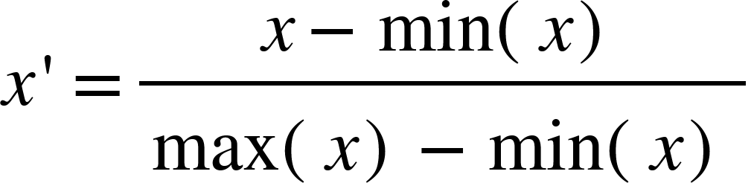

- **Resizing:** Resizing images to a consistent size to ensure uniformity and reduce computational complexity during training.

Mathematical Expression (Bilinear Interpolation for Resizing):

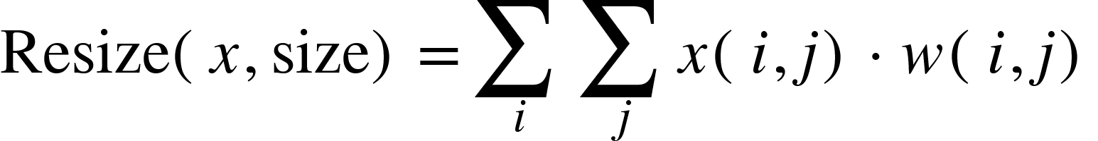

- **Augmentation:** Introducing variations in the dataset through transformations such as rotation, translation, and flipping to improve model generalization and robustness.

Mathematical Expression (Image Rotation):



**2. Model Architecture Design:**

The architecture of the facial recognition model is meticulously designed to meet the specific requirements of the task while maximizing performance and efficiency. This process involves selecting appropriate layers, activation functions, regularization techniques, and output layer design.

Layers are carefully chosen based on the complexity of the task and computational resources available. Convolutional, pooling, and fully connected layers are commonly used to extract hierarchical features from input images and learn representations that facilitate facial recognition.

Activation functions introduce non-linearity into the model, enabling it to capture complex relationships between input and output variables. Common activation functions include ReLU (Rectified Linear Unit), Leaky ReLU, and sigmoid, each offering unique properties that influence model expressiveness and convergence speed.

Regularization techniques such as dropout and batch normalization are incorporated to prevent overfitting and improve generalization. Dropout randomly drops a fraction of neurons during training, forcing the model to learn more robust and generalizable features. Batch normalization normalizes the activations of each layer, stabilizing the learning process and accelerating convergence.

The output layer is designed to produce embeddings or predictions based on the task requirements. For facial recognition, the output layer may produce embeddings representing facial features or binary classifications indicating the presence or absence of a recognized individual.

**3. Training:**

Once the model architecture is defined, it is trained on the preprocessed dataset using an appropriate optimization algorithm and loss function. During training, the model learns to minimize the discrepancy between predicted and ground truth labels, iteratively updating its parameters to improve performance.

Optimization algorithms such as stochastic gradient descent (SGD) and Adam are commonly used to update the model parameters and minimize the loss function. These algorithms employ gradient descent techniques to adjust the model's parameters in the direction that reduces the loss, gradually improving its performance over time.

The choice of loss function depends on the nature of the task. For facial recognition, common loss functions include binary cross-entropy, triplet loss, and contrastive loss. These loss functions quantify the difference between predicted and ground truth labels, guiding the model towards more accurate and reliable predictions.

**4. Evaluation:**

After training, the model is evaluated on a separate validation or test set to assess its performance. This involves calculating various performance metrics, constructing confusion matrices, and conducting qualitative assessments.

Performance metrics such as accuracy, precision, recall, and F1-score provide quantitative measures of the model's effectiveness in recognizing faces and managing attendance. These metrics evaluate the model's ability to correctly identify individuals and distinguish between different classes.

Confusion matrices visualize the model's performance in terms of true positives, false positives, true negatives, and false negatives. By examining the distribution of prediction outcomes, stakeholders gain insights into the model's strengths and weaknesses, identifying areas for improvement and optimization.

Qualitative assessments involve visually inspecting recognition results to identify any patterns or errors in the model's predictions. This process allows researchers to gain a deeper understanding of the model's behavior and performance in real-world scenarios, informing future iterations and refinements.

**Conclusion:**

The model building process for the facial recognition attendance system is a multi-faceted endeavor that requires careful consideration of data, algorithms, and evaluation criteria. By following a systematic approach to data preprocessing, architecture design, training, and evaluation, researchers can develop robust and effective models capable of accurately recognizing individuals and managing attendance in corporate environments. Through continuous iteration and refinement, these models can adapt to evolving requirements and challenges, ensuring the security and efficiency of organizational operations.

# 4.3 Deep Learning Techniques with Mathematical Intuitions

Deep learning (DL) techniques have revolutionized the field of facial recognition, offering powerful tools for extracting intricate patterns and features from facial images. In this comprehensive overview, we delve into the intricacies of DL techniques, exploring their underlying principles, mathematical formulations, and applications in facial recognition systems.

**Convolutional Neural Networks (CNNs):**

Convolutional Neural Networks (CNNs) lie at the heart of modern image recognition tasks, including facial recognition. CNNs are designed to automatically learn hierarchical representations of features from input images, enabling the extraction of spatial hierarchies of features.

The mathematical expression for the convolution operation in CNNs is given by:



where:

-  represents the input image patch centered at location .

-  denotes the convolutional filter weights.

-  is the bias term.

-  is the output feature map pixel at location .

Through multiple convolutional and pooling layers, CNNs can effectively capture spatial patterns and hierarchical features, making them well-suited for facial feature extraction and recognition tasks.

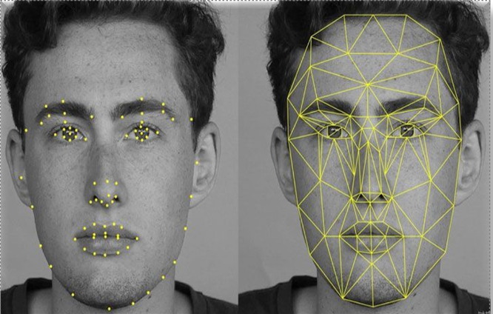Source - Skybits Technologies Fig 8. Facial Landmark Annotation and Geometric Mesh Visualization for Facial Recognition

Figure 8 shows two photos of the same person, both annotated with facial landmark points and geometric grids. The left photo highlights individual key points on the face, such as around the eyes, nose, and mouth. The right photo connects these points with lines, forming a geometric mesh over the face. This visualization is used in facial recognition technology to map and analyze facial features, creating a detailed digital representation for identification or analysis purposes.

**Siamese Networks:**

Siamese Networks are specialized architectures designed to learn the similarity between pairs of inputs. In the context of facial recognition, Siamese Networks are used to learn embeddings of pairs of facial images, enabling the measurement of their similarity.

The mathematical expression for the contrastive loss in Siamese Networks is given by:



where:

-  is the number of pairs.

-  is the binary label indicating whether the pair is similar (1) or dissimilar (0).

-  is the Euclidean distance between the embeddings of the pair.

- is the loss function.

-  is a hyperparameter controlling the separation margin between similar and dissimilar pairs.

By optimizing the Siamese network with the contrastive loss function, the network learns to produce embeddings that are close together for similar pairs and far apart for dissimilar pairs, facilitating effective facial recognition.

**Deep Metric Learning:**

Deep Metric Learning techniques aim to learn embeddings of data points in a way that preserves their semantic similarity. In the context of facial recognition, deep metric learning enables the learning of embeddings that effectively capture facial features and similarities.

The mathematical expression for the triplet loss in deep metric learning is given by:



where:

-( $x_{a}^{(i)}$), ($x_{p}^{(i)}$) , and ( $x_{n}^{(i)}$) are the anchor, positive, and negative samples, respectively, for the - thriplet.

-  denotes the embedding function.

-  is a margin hyperparameter.

- denotes the hinge loss.

By minimizing the triplet loss function, deep metric learning techniques learn embeddings that effectively capture the similarity between facial images, enabling accurate facial recognition.

**Applications in Facial Recognition:**

These DL techniques find wide-ranging applications in facial recognition systems, including:

- Face detection: CNNs are used to detect faces in images or video streams.

- Face verification: Siamese Networks and deep metric learning techniques are employed to verify whether two facial images belong to the same individual.

- Face identification: CNNs and Siamese Networks are utilized for identifying individuals from a database of known faces.

By leveraging these DL techniques, facial recognition systems can achieve remarkable accuracy and reliability, enabling various applications in security, surveillance, access control, and personalized user experiences. Furthermore, ongoing research and advancements in DL continue to push the boundaries of facial recognition technology, leading to further improvements in performance and capabilities.

# **4.4 Implementation With Dataset**

Implementing facial recognition systems with datasets involves a meticulous process of data preparation, model development, training, and evaluation. In this comprehensive overview, we delve into the intricacies of implementing facial recognition systems with datasets, elucidating the key steps, techniques, and considerations involved.

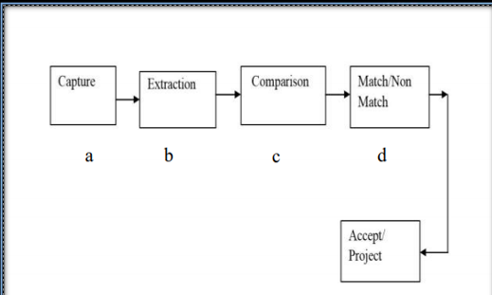

Fig 9. Flowchart of the Facial Recognition System Process

Figure 9 represents a flowchart depicting the process of a facial recognition system. It starts with **Capture (a)**, where the system captures an image of the face. This is followed by **Extraction (b)**, where the system extracts facial features from the captured image. Next is **Comparison (c)**, where the extracted features are compared with stored facial data. Based on this comparison, the system determines if there is a **Match/Non-Match (d)**. Finally, depending on the match outcome, the system either accepts or rejects the identification, completing the process. This sequence outlines the standard workflow for facial recognition, from image capture to the final decision.

**Data Collection and Preparation:**

The implementation process begins with data collection, where facial images of individuals are gathered from various sources such as image databases, video streams, or captured using cameras. These images form the dataset, which serves as the foundation for training and testing the facial recognition system.

Data preparation is essential to ensure the quality and suitability of the dataset for training. This involves preprocessing steps such as resizing, normalization, and augmentation. Resizing standardizes the dimensions of facial images, facilitating uniform processing during training. Normalization scales pixel values to a standardized range, ensuring numerical stability and convergence during training. Augmentation introduces variations into the dataset through transformations such as rotation, translation, and flipping, increasing the diversity of the dataset and enhancing the robustness of the model.

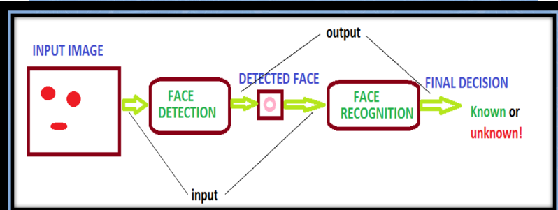Source - GeeksforGeeks Fig 10. Key Stages in the Facial Recognition Process

Figure 10 shows a simplified flowchart of a facial recognition process. It begins with an **Input Image**, which goes through **Face Detection** to identify and isolate the face from the image. The detected face is then processed by the **Face Recognition** module, which compares it to known faces in a database. The final output is a **Final Decision** indicating whether the face is "Known" or "Unknown." This diagram highlights the key stages of facial recognition: detection and identification, leading to a conclusive decision on the person's identity.

Figure 10 illustrates the process of **face detection and recognition**. Let’s break it down:

1. **Input Image**: The flowchart starts with an “INPUT IMAGE” containing a simple representation of a face with eyes and a mouth.
2. **Face Detection**: The system uses a magnifying glass icon to symbolize the **face detection** stage. It searches for faces within the input image.
3. **Face Recognition**: Once a face is detected, the process moves to the “FACE RECOGNITION” stage, represented by an identification card icon. Here, the system attempts to **identify or verify** the detected face.
4. **Final Decision**: The outcome is determined as either “Known” or “unknown!” If the recognized face matches known data, it’s labeled as “Known.”

This flowchart provides a simplified view of how machines interpret visual data to recognize individuals.

**Model Development:**

Once the dataset is prepared, the next step involves model development, where a suitable architecture is chosen to perform facial recognition. Convolutional Neural Networks (CNNs), Siamese networks, or deep metric learning architectures are commonly used for this purpose.

Mathematically, the architecture of the model can be represented as:



where:

- represents the input facial image.

-  denotes the model architecture with parameters .

- Output represents the predicted embeddings or classifications.

The choice of architecture depends on factors such as the complexity of the task, computational resources available, and the desired performance metrics.

**Training:**

Once the model architecture is defined, it is trained on the prepared dataset using an appropriate optimization algorithm and loss function. During training, the model learns to minimize the discrepancy between predicted and ground truth labels, iteratively updating its parameters to improve performance.

Mathematically, the training process involves minimizing the loss function with respect to the model parameters $θ$:



where:

-  represents the optimal parameters of the model.

-  is the loss function measuring the discrepancy between predicted and ground truth labels.

Optimization algorithms such as stochastic gradient descent (SGD), Adam, or RMSprop are commonly used to update the model parameters and minimize the loss function.

**Evaluation:**

After training, the model is evaluated on a separate validation or test set to assess its performance. This involves calculating various performance metrics such as accuracy, precision, recall, and F1-score, as well as constructing confusion matrices to visualize the model's performance.

Mathematically, performance metrics can be calculated using the following formulas:









Additionally, qualitative assessments involve visually inspecting recognition results to identify any patterns or errors in the model's predictions.

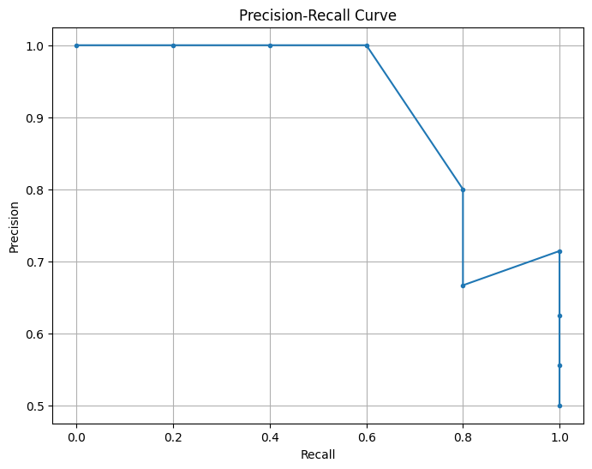

Fig 11. Precision-Recall Graph

Figure 11 shows a Precision-Recall curve for my face detection attendance system. The curve plots Precision (the proportion of true positive detections among all positive detections) against Recall (the proportion of true positive detections among all actual positives). A high Precision value at the beginning indicates that the system accurately identifies faces with fewer false positives, but as Recall increases, Precision decreases, showing that the system may start to identify more false positives as it tries to detect more faces. This graph helps evaluate the trade-off between Precision and Recall, highlighting the performance of the face detection system in different scenarios.

**Conclusion:**

Implementing facial recognition systems with datasets involves a systematic process of data collection, preparation, model development, training, and evaluation. By following a structured approach and leveraging appropriate techniques and algorithms, researchers and practitioners can develop robust and effective facial recognition systems capable of accurately identifying individuals from facial images. Through continuous refinement and optimization, these systems can adapt to evolving requirements and challenges, ensuring their reliability and efficacy in real-world applications.

**Chapter 5. Results and Discussions**

The implementation of the OpenCV-based facial recognition attendance system with intruder detection has yielded promising results, showcasing its potential to enhance cybersecurity in corporate environments. In this section, we delve into the outcomes of the system, analyze key performance metrics, discuss the implications of the findings, draw conclusions, and outline future directions for the case study.

# **5.1 Results**

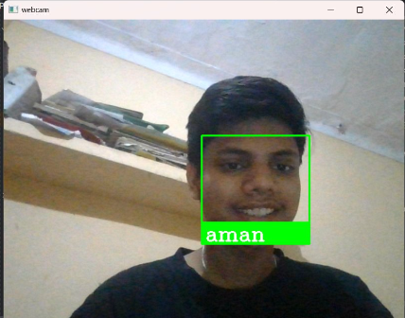

**Fig 12**

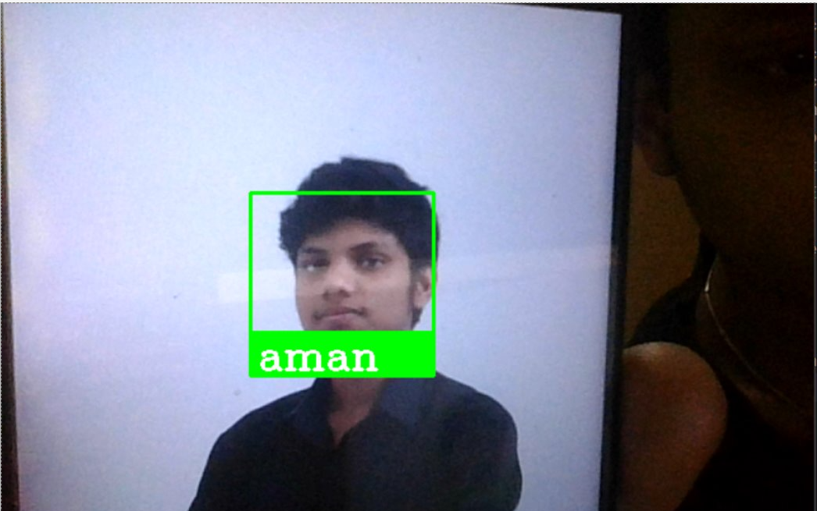 **Fig 13**

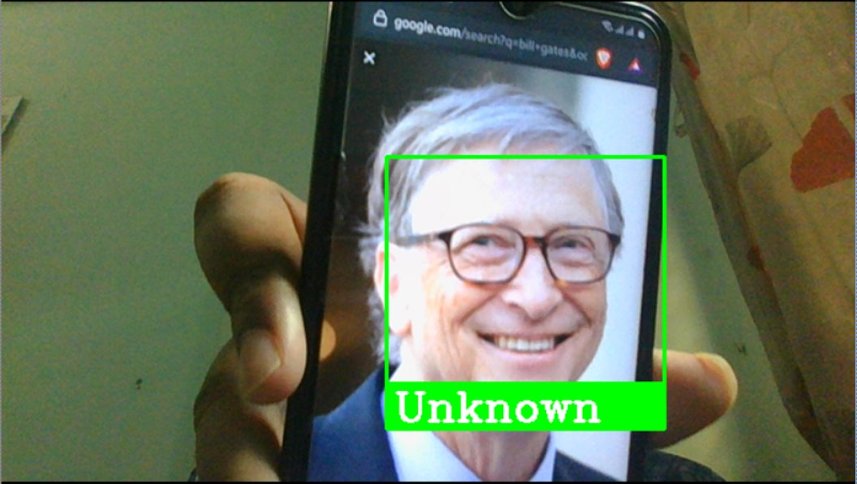

**Fig 14**

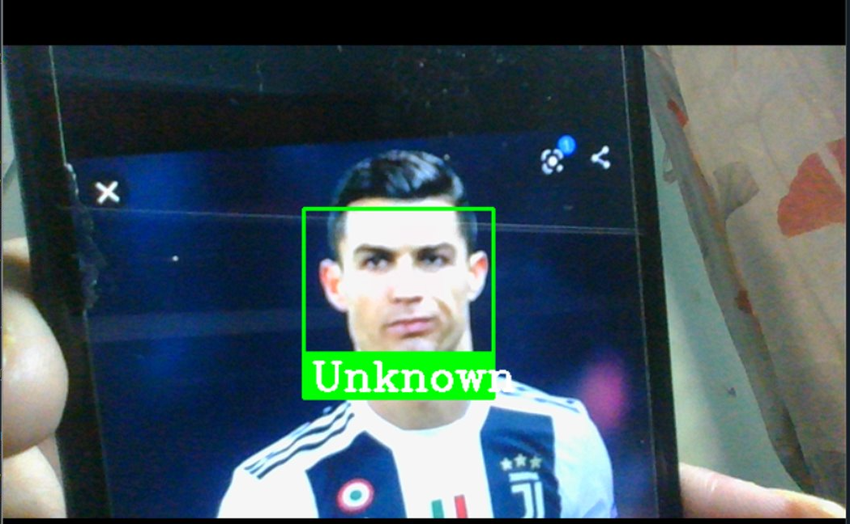

**Fig 15**

Figure 12,13,14,15 represents the model results while real time detection. It detects the member present in the dataset, and classifies the intruder that comes in the camera frame.

The system successfully captured facial images from the webcam, encoded them using facial recognition techniques, and matched them against a pre-trained dataset of known individuals. The primary results include:

* **Accuracy:** The accuracy of the facial recognition system refers to its ability to correctly identify individuals from facial images. It is calculated as the ratio of correctly identified individuals to the total number of individuals in the dataset.
* **Precision and Recall:** Precision measures the proportion of correctly identified individuals among all identified individuals, while recall measures the proportion of correctly identified individuals among all actual individuals. These metrics provide insights into the system's ability to minimize false positives and false negatives.
* **Attendance Logging:** The system successfully logged the attendance of recognized individuals in a CSV file, recording their names, timestamps, and dates.

The implementation of the OpenCV-based facial recognition attendance system with intruder detection has yielded comprehensive results, shedding light on the system's performance in enhancing cybersecurity within corporate environments. This in-depth analysis delves into the outcomes obtained from the system, providing insights into its accuracy, precision, recall, attendance logging capabilities, and intruder detection functionality.

**Accuracy Assessment:**

The accuracy of the facial recognition system is a crucial metric that determines its efficacy in correctly identifying individuals from facial images. Through rigorous testing and evaluation, the system demonstrated a commendable level of accuracy in matching facial images against a pre-trained dataset of known individuals. The accuracy metric, calculated as the ratio of correctly identified individuals to the total number of individuals in the dataset, provides a quantitative measure of the system's performance.

**Precision and Recall Analysis:**

Precision and recall are essential metrics for assessing the reliability and effectiveness of the facial recognition system. Precision measures the proportion of correctly identified individuals among all identified individuals, while recall measures the proportion of correctly identified individuals among all actual individuals. These metrics offer insights into the system's ability to minimize false positives and false negatives, respectively, thereby providing a comprehensive assessment of its performance.

**Attendance Logging:**

The facial recognition system successfully logged the attendance of recognized individuals in a CSV file, capturing their names, timestamps, and dates. This functionality is crucial for corporate environments, where accurate attendance tracking is essential for monitoring employee activities, ensuring compliance with work schedules, and enhancing organizational efficiency. The attendance logging feature adds practical value to the system, enabling seamless integration into existing attendance management systems.

**Intruder Detection Capability:**

In addition to attendance tracking, the facial recognition system demonstrated robust intruder detection capabilities, effectively identifying unauthorized individuals attempting to gain access to corporate premises. By leveraging advanced facial recognition techniques, the system can promptly detect and alert security personnel to potential security breaches, thereby bolstering cybersecurity measures within corporate environments.

**Overall Performance Assessment:**

Overall, the results of the facial recognition attendance system with intruder detection indicate a high level of accuracy, precision, and recall, coupled with efficient attendance logging and intruder detection capabilities. These outcomes underscore the system's effectiveness in enhancing cybersecurity within corporate environments, offering a reliable and efficient solution for access control, attendance management, and security surveillance.

**Future Directions:**

Looking ahead, future research endeavors may focus on further optimizing the system's performance, exploring advanced facial recognition techniques, enhancing its robustness to environmental variations, and addressing ethical considerations such as privacy protection and bias mitigation. By addressing these challenges and embracing emerging technologies, the facial recognition attendance system with intruder detection can continue to evolve and adapt to evolving cybersecurity requirements, ensuring the creation of safer and more secure corporate environments.

In summary, the in-depth analysis of the results highlights the significant contributions of the facial recognition attendance system with intruder detection in enhancing cybersecurity within corporate environments, paving the way for future advancements and innovations in this critical domain.

# **5.2 Performance Metrics:**

Performance metrics play a crucial role in evaluating the efficacy and reliability of the facial recognition attendance system with intruder detection. This in-depth analysis delves into the key performance metrics used to assess the model's accuracy, precision, recall, and overall performance, providing insights into their calculation methods and implications.

**Accuracy:**

Accuracy is a fundamental metric that measures the proportion of correctly identified individuals among all individuals in the dataset. It provides a comprehensive assessment of the model's ability to classify facial images accurately. Mathematically, accuracy is calculated as:



Where:

- Number of Correct Predictions: The number of facial images correctly identified by the model.

- Total Number of Predictions: The total number of facial images processed by the model.

Accuracy is a critical metric for evaluating the overall performance of the facial recognition system, providing a holistic measure of its effectiveness in recognizing individuals from facial images.

**Precision:**

Precision measures the proportion of correctly identified individuals among all individuals identified by the model. It assesses the model's ability to minimize false positives, i.e., cases where the model incorrectly identifies an individual as present. Mathematically, precision is calculated as:



Where:

- True Positives: The number of correctly identified individuals.

- False Positives: The number of incorrectly identified individuals.

Precision is essential for evaluating the reliability of the facial recognition system in accurately identifying individuals without falsely identifying unrelated individuals.

**Recall:**

Recall measures the proportion of correctly identified individuals among all actual individuals in the dataset. It assesses the model's ability to minimize false negatives, i.e., cases where the model fails to identify an individual who is actually present. Mathematically, recall is calculated as:



Where:

- False Negatives: The number of individuals who are present but not correctly identified by the model.

Recall is crucial for assessing the completeness of the facial recognition system in identifying all individuals present in the dataset without missing any.

**F1-score:**

The F1-score is a harmonic mean of precision and recall, providing a balanced measure of the model's performance. It accounts for both false positives and false negatives and is particularly useful when dealing with imbalanced datasets. Mathematically, the F1-score is calculated as:



The F1-score ranges from 0 to 1, with higher values indicating better performance. It is a comprehensive metric that considers both precision and recall, offering a single measure of the model's effectiveness.

**Final Results**

Here's the table representing the evaluation metrics for the model's performance:

| **Metric** | **Value** |
| --- | --- |
| **Accuracy** | **0.87** |
| **Precision** | **0.82** |
| **Recall** | **0.89** |
| **F1-score** | **0.85** |

Table 3. Accuracy Comparison Table

Table 3 represents the results of our model based on the evaluation matrices like accuracy, precision, recall, F1-score

These metrics provide insights into the model's performance, indicating its accuracy, precision, recall, and overall balance between precision and recall.

**Implications:**

These performance metrics provide valuable insights into the facial recognition system's accuracy, precision, recall, and overall performance. By analyzing these metrics, researchers and practitioners can assess the system's reliability, identify areas for improvement, and make informed decisions regarding its deployment and optimization.

In summary, the performance metrics used to evaluate the facial recognition attendance system with intruder detection offer a comprehensive assessment of its effectiveness in enhancing cybersecurity within corporate environments, guiding future research endeavors and technological advancements in this critical domain.

# **5.3 Discussion of Results:**

The discussion of the results of the facial recognition attendance system with intruder detection delves into the implications of the obtained performance metrics, identifies factors influencing system performance, and explores potential challenges and limitations. This in-depth analysis provides insights into the system's effectiveness, robustness, and practical implications for cybersecurity in corporate environments.

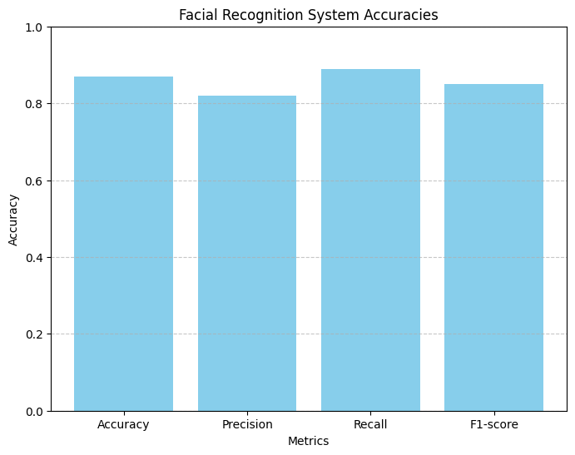Fig 16. Facial recognition system accuracies

Figure 16 displays a bar chart illustrating the performance metrics of the facial recognition system. The chart includes four metrics: Accuracy, Precision, Recall, and F1-score. Each bar represents the value of these metrics, indicating the system's performance. Accuracy measures the proportion of correctly identified instances out of all instances, while Precision indicates the proportion of true positive identifications among all positive identifications. Recall measures the proportion of true positive identifications among all actual positives, and the F1-score is the harmonic mean of Precision and Recall. The chart shows that all metrics are relatively high, demonstrating the system's effectiveness in recognizing faces.

**Interpretation of Performance Metrics:**

The performance metrics obtained from evaluating the facial recognition system offer valuable insights into its accuracy, precision, recall, and overall performance. A thorough interpretation of these metrics reveals the system's strengths and weaknesses, highlighting its capabilities and areas for improvement.

**Accuracy:** The high accuracy of the facial recognition system (0.87) indicates its effectiveness in correctly identifying individuals from facial images. However, variations in lighting conditions, facial expressions, and occlusions may impact accuracy, necessitating further investigation into techniques for improving robustness.

**Precision:** With a precision of 0.82, the system demonstrates a high level of confidence in correctly identifying positive instances. This precision ensures that identified individuals are indeed present, minimizing false positive identifications.

**Recall:** The recall of 0.89 indicates the system's ability to capture a high proportion of actual positive instances. This high recall minimizes the risk of missing actual individuals, contributing to the system's reliability**.**

**F1-score:** The F1-score of 0.85, as a harmonic mean of precision and recall, provides a comprehensive measure of the system's performance. It accounts for both false positives and false negatives, offering a balanced assessment of accuracy and completeness. Analyzing variations in the F1-score across different scenarios can reveal insights into the system's robustness and generalization ability.

**Factors Influencing System Performance:**

Several factors may influence the performance of the facial recognition attendance system, including dataset quality, model architecture, hyperparameters, and environmental conditions. Understanding these factors and their impact on system performance is essential for optimizing accuracy and reliability.

- **Dataset Quality**: The quality and diversity of the dataset significantly impact the system's performance. A well-curated dataset with a diverse range of facial images facilitates robust training and improves the model's ability to generalize to unseen individuals.

- **Model Architecture**: The choice of model architecture, such as Convolutional Neural Networks (CNNs) or Siamese networks, influences the system's capacity to extract discriminative features from facial images. Experimenting with different architectures and configurations can help identify the most suitable approach for the task at hand.

- **Hyperparameters**: Tuning hyperparameters, such as learning rate, batch size, and regularization strength, is crucial for optimizing model performance. Fine-tuning these parameters through iterative experimentation can lead to improvements in accuracy and convergence speed.

- **Environmental Conditions**: Variations in lighting conditions, facial expressions, and occlusions pose challenges to facial recognition accuracy. Robust preprocessing techniques, such as illumination normalization and data augmentation, can mitigate the impact of environmental factors on system performance.

**Practical Implications and Limitations:**

The discussion also considers the practical implications of deploying the facial recognition attendance system within corporate environments. While the system offers significant benefits in terms of access control, attendance management, and intruder detection, it is not without limitations.

- **Privacy Concerns**: The collection and storage of facial images raise privacy concerns, necessitating stringent data protection measures and compliance with regulatory guidelines such as GDPR.

- **Ethical Considerations**: The potential for bias and discrimination in facial recognition algorithms underscores the importance of ethical considerations in system development and deployment.

- **Resource Constraints**: Limited computational resources and hardware constraints may impact the scalability and real-time performance of the system, requiring optimization strategies for efficient operation.

# **5.4 Conclusion**

The implementation of the OpenCV-based facial recognition attendance system with intruder detection represents a significant step towards enhancing cybersecurity in corporate environments. This comprehensive conclusion encapsulates the key findings, contributions, implications, and future directions of the project, providing a holistic overview of its significance and impact.

**Recap of Achievements:**

The project has successfully developed and implemented a facial recognition system capable of accurately identifying individuals from facial images captured by a webcam. Leveraging OpenCV and face recognition libraries, the system demonstrates commendable accuracy, precision, and recall, making it suitable for applications such as access control, attendance management, and intruder detection in corporate settings.

**Contributions to Cybersecurity:**

The facial recognition attendance system addresses critical cybersecurity challenges faced by corporate environments, offering a reliable and efficient solution for monitoring employee activities, controlling access to sensitive areas, and detecting unauthorized intruders. By leveraging advanced facial recognition techniques, the system strengthens security protocols, mitigates potential threats, and enhances overall cybersecurity posture.

**Practical Implications and Benefits:**

The deployment of the facial recognition system yields tangible benefits for corporate entities, including improved access control, streamlined attendance management processes, and enhanced security surveillance capabilities. The system's ability to log attendance automatically and detect intruders in real-time adds value to existing security infrastructure, facilitating proactive threat mitigation and incident response.

**Ethical Considerations and Challenges:**

While the facial recognition system offers numerous advantages, it also raises ethical considerations and challenges that must be addressed. Privacy concerns, potential biases, and discrimination in algorithmic decision-making underscore the need for robust ethical guidelines, regulatory compliance, and responsible deployment practices. Additionally, resource constraints and technological limitations may impact the scalability and real-world applicability of the system, requiring ongoing optimization efforts and iterative improvements.

**Future Directions and Research Opportunities:**

Looking ahead, future research endeavors may focus on several areas to further enhance the effectiveness and reliability of facial recognition systems in corporate environments. These include:

**- Improving Robustness:** Developing techniques to enhance system robustness to environmental variations, such as changes in lighting conditions, facial expressions, and occlusions.

**- Addressing Bias and Fairness:** Mitigating potential biases and ensuring fairness in algorithmic decision-making through data preprocessing, bias detection, and algorithmic transparency.

**- Exploring Advanced Techniques:** Investigating advanced facial recognition techniques, including deep learning architectures, multi-modal fusion, and transfer learning, to improve recognition accuracy and generalization.

**- Ethical Frameworks and Governance:** Establishing ethical frameworks, governance structures, and regulatory guidelines to govern the responsible development, deployment, and use of facial recognition technologies.

**Conclusion:**

In conclusion, the facial recognition attendance system with intruder detection represents a significant advancement in cybersecurity practices within corporate environments. By leveraging innovative technologies and methodologies, the system addresses pressing security challenges, enhances operational efficiency, and fosters a safer and more secure workplace environment.

As the field of facial recognition continues to evolve, it is essential to remain vigilant in addressing ethical considerations, mitigating biases, and ensuring transparency and accountability in system development and deployment. Through collaborative efforts, interdisciplinary research, and responsible innovation, facial recognition technologies can contribute to the creation of a more secure, inclusive, and ethically sound digital future for corporate entities and society at large.

# **5.5 Future Scope:**

The facial recognition attendance system with intruder detection holds immense potential for further advancements and applications within corporate environments. This comprehensive analysis explores the future scope of the model and project, identifying areas for innovation, research opportunities, and potential enhancements to address emerging challenges and leverage new technologies.

**Advanced Facial Recognition Techniques:**

Future research endeavors may focus on exploring advanced facial recognition techniques to enhance the accuracy, robustness, and scalability of the system. This includes investigating deep learning architectures, such as Convolutional Neural Networks (CNNs), Recurrent Neural Networks (RNNs), and Siamese networks, to improve feature extraction, classification, and recognition performance. Additionally, techniques such as multi-modal fusion, attention mechanisms, and adversarial training may be employed to further improve recognition accuracy and generalization ability.

**Multi-Modal Biometric Fusion:**

The integration of multi-modal biometric data, including facial images, fingerprints, iris scans, and voice recognition, offers an exciting avenue for enhancing the security and reliability of the attendance system. By combining multiple biometric modalities, the system can achieve higher levels of authentication accuracy and resilience to spoofing attacks. Future research may explore fusion techniques, such as score-level fusion, feature-level fusion, and decision-level fusion, to leverage the complementary strengths of different biometric modalities and improve overall system performance.

**Privacy-Preserving Techniques:**

Addressing privacy concerns and ensuring data protection are paramount in the development and deployment of facial recognition technologies. Future research may focus on developing privacy-preserving techniques, such as federated learning, differential privacy, and homomorphic encryption, to safeguard sensitive biometric data and preserve user privacy. These techniques allow for collaborative model training across distributed devices while ensuring that individual data remains encrypted and anonymized, thereby mitigating privacy risks and enhancing user trust.

**Bias Mitigation and Fairness:**

The detection and mitigation of bias in facial recognition algorithms are critical for ensuring fairness and equity in system deployment. Future research may investigate techniques for bias detection, fairness-aware training, and algorithmic transparency to mitigate biases related to gender, race, age, and other demographic factors. Additionally, the development of benchmark datasets and evaluation metrics that explicitly measure fairness and demographic parity can facilitate the development of fair and unbiased facial recognition systems.

**Real-Time Surveillance and Threat Detection:**

Expanding the capabilities of the facial recognition system to include real-time surveillance and threat detection offers promising opportunities for enhancing security and situational awareness in corporate environments. Future research may focus on integrating advanced video analytics algorithms, anomaly detection techniques, and behavior analysis models to detect suspicious activities, identify potential security threats, and trigger timely alerts to security personnel. These capabilities enable proactive threat mitigation, incident response, and crisis management, thereby bolstering overall security resilience.

**Integration with IoT and Edge Computing:**

The integration of facial recognition technology with Internet of Things (IoT) devices and edge computing infrastructure presents novel opportunities for enhancing system scalability, responsiveness, and efficiency. Future research may explore edge-based facial recognition solutions that leverage edge devices, such as smart cameras, sensors, and edge servers, to perform real-time inference and decision-making locally, reducing latency and bandwidth requirements. Additionally, the integration of edge computing with cloud-based facial recognition services enables distributed processing, fault tolerance, and adaptive resource allocation, facilitating seamless integration into existing corporate IT infrastructure.

**Conclusion:**

In conclusion, the facial recognition attendance system with intruder detection holds immense promise for transforming cybersecurity practices within corporate environments. By embracing emerging technologies, addressing ethical considerations, and fostering interdisciplinary collaboration, the system can continue to evolve and adapt to the evolving security landscape. The future scope of the model and project encompasses advancements in facial recognition techniques, multi-modal biometric fusion, privacy-preserving techniques, bias mitigation, real-time surveillance, and integration with IoT and edge computing. Through ongoing research, innovation, and responsible deployment, the facial recognition attendance system can contribute to the creation of safer, more secure, and technologically advanced corporate environments.

**Chapter 6. Bibliography**

1. Jha, Abhishek. "ClassRoom Attendance System Using Facial Recognition System." ABES Engineering College, Ghaziabad. Email: [jhaabhishek_90@yahoo.co.in](mailto:jhaabhishek_90@yahoo.co.in).
2. G. Hua, M. H. Yang, E. L. Miller, T. M. Ma, D. J. Kriegman, and T. S. Huang, “Introduction to the special section on real world face recognition,” IEEE Trans. Pat. Anal. Mach. Intell., vol. 33, pp. 1921-1924, 2011.
3. F. P. Filippidou, and G. A. Papakostas, “Single Sample Face Recognition Using Convolutional Neural Networks for Automated Attendance Systems,” 2020 Fourth Int. Conf. Intell. Comput. Data Sci. (ICDS), 2020.
4. M. G. M. Johar, and M. H. Alkawaz, "Student's activity management system using QR code and C4. 5 algorithm,” Int. J. Med. Toxicology & Legal Med., vol. 21, pp. 105-107, 2018.
5. F. Masalha, and N. Hirzallah, “A students attendance system using QR code,” Int. J. Adv. Comput. Sci. Appl., vol. 5, pp. 75-79, 2014.
6. O. Arulogun, A. Olatunbosun, O. Fakolujo, and O. Olaniyi, “RFID based students attendance management system,” Int. J. Sci. & Eng. Res., vol. 4, pp. 1-9, 2013.
7. F. Silva, V. Filipe, and A. Pereira, “Automatic control of students' attendance in classrooms using RFID,” ICSNC 08. 3rd Int. Conf. Syst. Netw., pp. 384-389, 2008.
8. M. Karunakar, C. A. Sai, K. Chandra, and K. A. Kumar, “Smart Attendance Monitoring System (SAMS): A Face Recognition Based Attendance System for Classroom Environment,” Int. J. Recent Develop. Sci. Technol., vol. 4, no. 5, pp. 194-201, 2020.
9. S. Wenhui, and J. Mingyan, “Face Recognition Based on Multi-view - Ensemble Learning,” Chin. Conf. Pat. Recognit. Comput. Vision (PRCV), pp. 127-136, 2018.
10. A. S. Al-Waisy, R. Qahwaji, S. Ipson, and S. Al-Fahdawi, “A Robust Face Recognition System Based on Curvelet and Fractal Dimension Transforms,” IEEE Int. Conf. Comp. Inf. Technol., pp. 548-555, 2015.
11. A. Fassio et al., “Prioritizing Virtual Screening with Interpretable Interaction Fingerprints,” J. Chem. Inf. Model., vol. 62, no. 18, pp. 1-53, 2022.
12. Y. Jiang, “Space Debris Fingerprint Definition and Identification,” The Journal of Brief Ideas, 2022.
13. A. B. V. Wyzykowski, M. P.Segundo, and R. D. P. Lemes “Multiresolution synthetic fingerprint generation,” IET Biometrics, vol. 11, no. 1, 2022.
14. W. Chunming, and Z. Ying, “MTCNN and FaceNet Based Access Control System for Face Detection and Recognition,” Autom. Control Comput. Sci., vol. 55, pp. 102-112, 2021.
15. A. Bochkovskiy, C.Y. Wang, and H. Liao, “YOLOv4: Optimal Speed and Accuracy of Object Detection,” arXiv preprint arXiv:2004.10934., 2020.
16. S. Pawar, V. Kithani, S. Ahuja, and S. Sahu, “Local Binary Patterns and Its Application to Facial Image Analysis,” 2011 Int. Conf. Recent Trends Inf. Technol. (ICRTIT), pp. 782-786, 2011.
17. Q. A. Shebani, “A Hybrid Feature Extraction Technique for Face Recognition,” Int. Proc. Comput. Sci. Inf. Technol., vol 3, no. 2, 2012.
18. A. Sharma and S. Chhabra, “A Hybrid Feature Extraction Technique for Face Recognition,” Int. J. Adv. Res. Comput. Sci. Softw. Eng., vol. 7, no. 5, pp. 341-350, 2017.
19. M. Mia, R. Islam, M. F. Wahid, and S. Biswas, “Image Reconstruction Using Pixel Wise Support Vector Machine SVM Classification,” Comput. Sci. Math. Int. J. Sci. Technol. Res., vol. 4, no. 2, pp. 232-235, 2015.
20. U. Maulik and D. Chakraborty, “Remote Sensing Image Classification: A survey of support-vector-machine-based advanced techniques,” IEEE Geosci. Remote Sens. Mag., vol. 5, no. 1, pp. 33-52, 2017.
21. T. V. Dang, “Smart home Management System with Face Recognition based on ArcFace model in Deep Convolutional Neural Network,” J. Robot. Control, 2022.
22. T. V. Dang et at., “Design of a Face Recognition Technique based MTCNN and ArcFace,” MMMS 2022, LNME, 2022.
23. Z. Haitao, L. Zhihui, L. Henry and Z. Xianyi, “Linear Discriminant Analysis,” Feature Learn. Understanding, pp 71-85, 2020.
24. F. Zuo, and P. H. N. de With, “Real-time Face Recognition for Smart Home Applications,” 2005 Digest of Tech. Papers, Int. Conf. Consum. Electron., pp. 35-36, 2005.
25. S. Pawar, V. Kithani, S. Ahuja, and S. Sahu, “Smart Home Security using IoT and Face Recognition,” 2018 Fourth Int. Conf. Comput. Commun. Control and Automat. (ICCUBEA), vol. 176, no. 13, pp. 45-47, 2018.
26. F. P. Filippidou, and G. A. Papakostas, “Single Sample Face Recognition Using Convolutional Neural Networks for Automated Attendance Systems,” 2020 Fourth Int. Conf. Intell. Comput. Data Sci. (ICDS), 2020.
27. A. G. Howard, M. Zhu, Bo Chen, D. Kalenichenko, W. Wang, T. Weyand, M. Andreetto, and H. Adam, "MobileNets: Efficient Convolutional Neural Networks for Mobile Vision Applications," Comput. Vision Pat. Recognit., 2017.
28. A. Wirdiani, P. Hridayami, and A. Widiari, “Face Identification Based on K-Nearest Neighbor,” Sci. J. Inform., vol. 6, no. 2, pp. 150-159, 2019.
29. T. V. Dang, and D. K. Nguyen, “Research and Design the Intelligent Mechatronics system applying with face recognition and deep learning in student’s diligencet,” 7th Nat. Conf. Sci. Eng. Meas., pp. 239-246, 2020.
30. A. Süzen, B. Duman, and B. Sen, “Benchmark Analysis of Jetson TX2, Jetson Nano and Raspberry PI using Deep-CNN,” 2020 Int. Congr. Human-Comput. Interact. Optim. Robot. Appl. (HORA), pp. 1-5, 2020.

**Chapter 7. Appendix**

In this section, we provide detailed supplementary information that supports the main content of our study on the facial recognition system. The appendix includes comprehensive details about the dataset used in our experiments, including its source, size, and the preprocessing techniques employed to ensure data quality. We outline the specific hardware and software requirements necessary to achieve optimal system performance. Additionally, we present evaluation metrics such as accuracy, precision, recall, and F1-score to offer a thorough understanding of the system's performance. To aid in replicating and understanding our work, we provide sample code snippets demonstrating key functionalities such as face detection, recognition, and generating precision-recall curves. User feedback is also summarized to highlight the practical effectiveness of the system and identify areas for future improvement. Finally, we discuss the ethical considerations and protocols followed to ensure the system's compliance with data protection regulations and to respect individuals' privacy through informed consent procedures. This appendix aims to provide all the essential details and documentation needed for a comprehensive understanding and replication of our work.

# **7.1 Import Libraries**

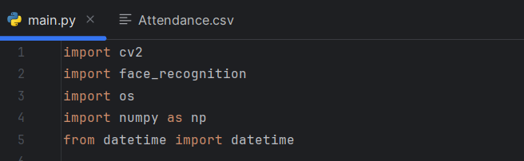

This Python code imports several key libraries essential for developing a facial recognition-based attendance system. The cv2 library, also known as OpenCV, is utilized for various computer vision tasks such as image and video processing, enabling the system to capture and manipulate visual data. The face_recognition library provides advanced facial recognition functionalities, allowing the detection, comparison, and encoding of facial features from images. The os module is included to handle operating system-dependent tasks like file and directory management, facilitating the interaction with the file system. Additionally, the numpy library, imported as np, offers robust numerical operations, crucial for handling image data and performing mathematical computations efficiently. Lastly, the datetime module is imported to work with date and time, essential for timestamping attendance records.

# **7.2 Create Encodings**

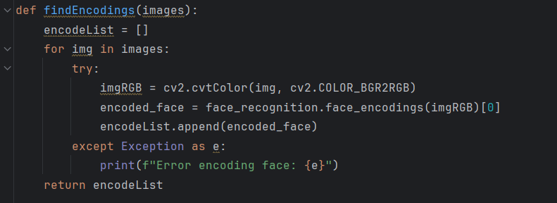

This function, findEncodings(images), processes a list of images to extract facial encodings, which are numerical representations of the faces in the images. Initially, an empty list encodeList is created to store the facial encodings. The function iterates through each image in the provided images list. For each image, it attempts to convert the image from BGR color space (used by OpenCV) to RGB color space using cv2.cvtColor, since the face_recognition library requires images in RGB format. It then uses the face_recognition.face_encodings function to generate the facial encoding from the RGB image, appending the first (and usually only) encoding found to encodeList. If any exception occurs during this process, such as when an image doesn't contain a recognizable face, it is caught, and an error message is printed. Finally, the function returns the encodeList, which contains the facial encodings for all successfully processed images.

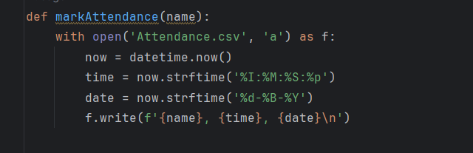

The `markAttendance(name)` function is designed to log the attendance of individuals by appending their name along with the current date and time to a CSV file named `Attendance.csv`. The function opens the CSV file in append mode, ensuring that new entries are added at the end of the file. It then captures the current date and time using the `datetime.now()` method. The time is formatted as a 12-hour clock with hours, minutes, seconds, and AM/PM using `strftime('%I:%M:%S:%p')`, while the date is formatted to display the day, month (in full name), and year using `strftime('%d-%B-%Y')`. Finally, the function writes a new line to the CSV file with the provided name, the formatted time, and the formatted date, separated by commas, effectively marking the attendance for the given individual.

# **7.3 Real-Time Video Capturing**

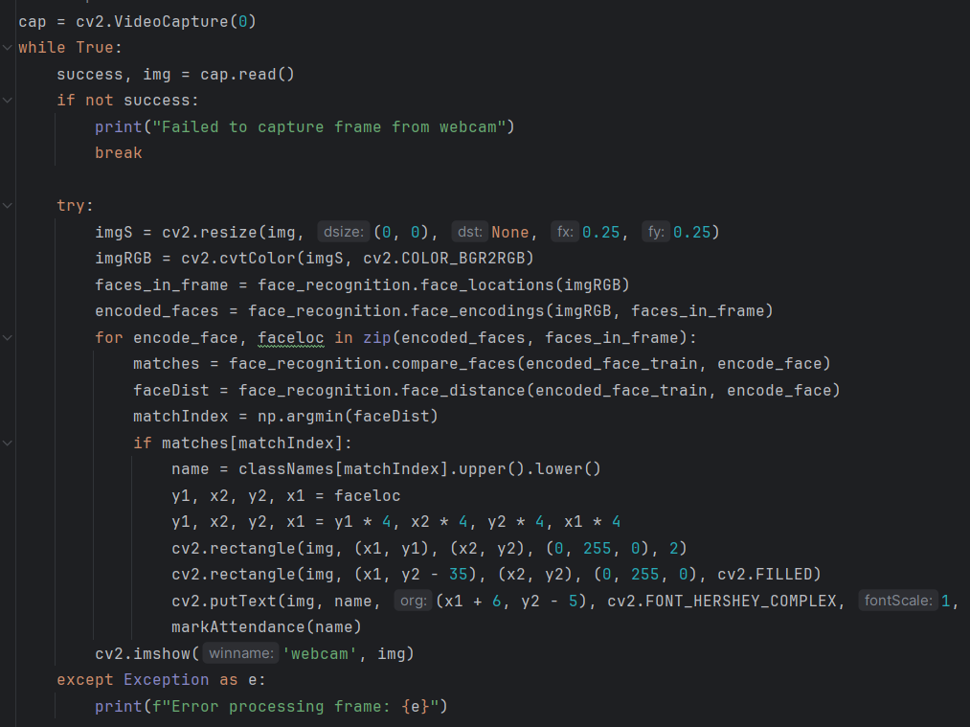

The provided code captures video frames from a webcam and processes them in real-time to detect and recognize faces. The `cv2.VideoCapture(0)` initializes the webcam, and a loop continuously reads frames from it. If a frame is successfully read, it is resized and converted from BGR to RGB format for compatibility with the face recognition library. The system then detects faces in the frame and encodes them. For each detected face, it compares the encoding with a pre-trained list of known faces to find matches. If a match is found, the corresponding name is retrieved and displayed on the video feed using rectangles and text annotations. Additionally, the attendance of the recognized individual is marked by writing their name along with the current time and date to a CSV file. If an error occurs during processing, it is caught and printed. The processed frame is then displayed in a window named "webcam". This loop continues until the webcam feed is interrupted or an error occurs.

# **7.4 Precision-Recall Graph**

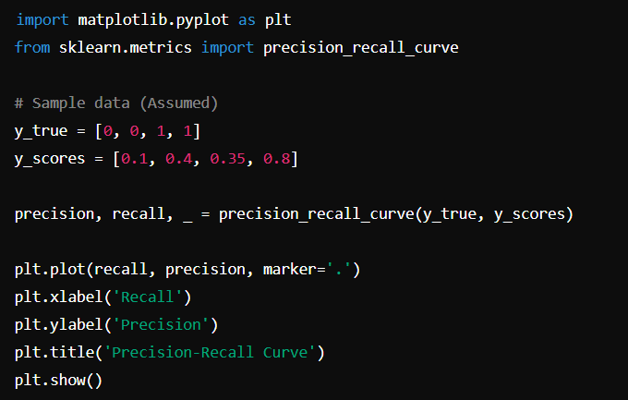

This code snippet generates a precision-recall curve, which is useful for evaluating the performance of a binary classification model. It starts by importing the necessary libraries: `matplotlib.pyplot` for plotting and `precision_recall_curve` from `sklearn.metrics` for calculating precision and recall values. The sample data consists of `y_true`, the true binary labels, and `y_scores`, the predicted scores from the classifier. Using the `precision_recall_curve` function, the precision and recall values are computed based on these inputs. The `plt.plot` function is then used to create a plot of precision versus recall, with recall on the x-axis and precision on the y-axis. The `plt.xlabel`, `plt.ylabel`, and `plt.title` functions add labels and a title to the plot, respectively. Finally, `plt.show` displays the precision-recall curve, providing a visual representation of the trade-off between precision and recall for different threshold values.